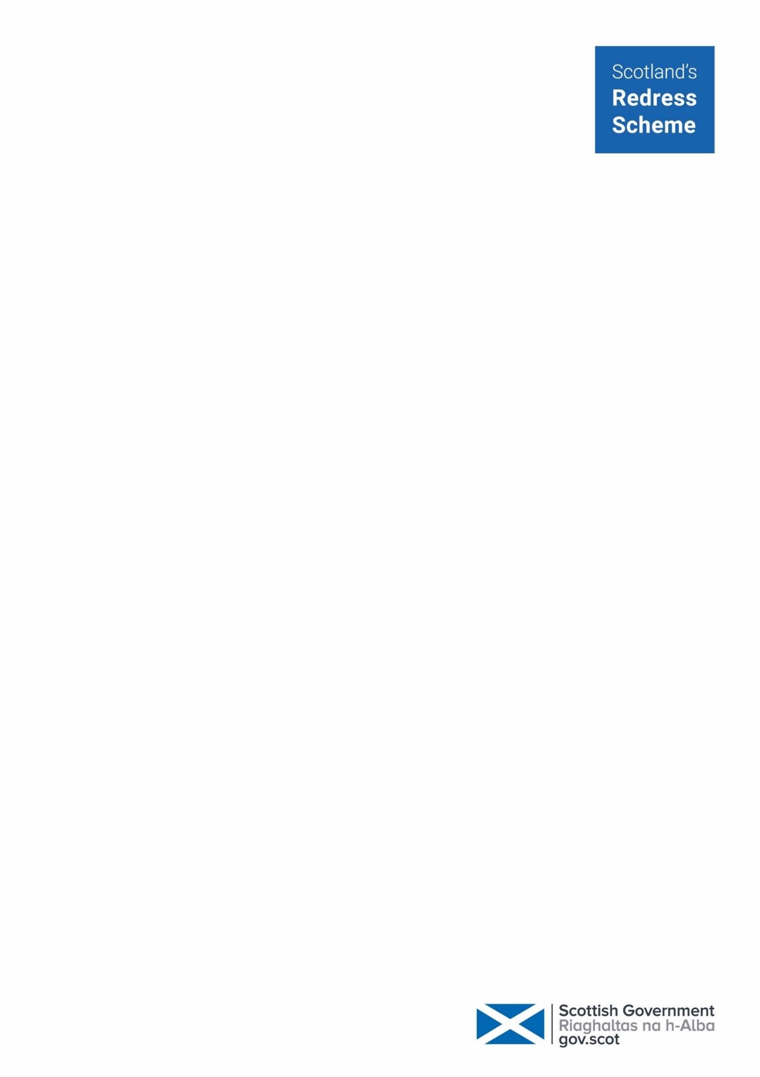
Confirming your identity

As part of your application to Scotland’s Redress Scheme we need to verify your identity.

Most people can quickly and easily verify their identity using our online verification service provided by ScotAccount.

If your identity can’t be verified using ScotAccount you can have your identity verified by a listed professional person.

Verification through ScotAccount

ScotAccount is the Scottish Government’s online identity verification service. You need to access ScotAccount via this link: https://verify.redress-scheme.scot

You will need an email address and phone number to create a ScotAccount.

You can verify your identity by taking a photo of yourself and a photo of a valid photo ID document or by answering a series of personalised questions about things like your financial history.
Once verified you’ll be asked to share your verified name, date of birth, and address with Scotland’s Redress Scheme. You must share all of these details to successfully verify your identity. These details are passed to Scotland’s Redress Scheme securely online by ScotAccount.

You will also be able to use your ScotAccount and verified details to access other Scottish Government services, without needing to verify your identity each time.

Verifying your identity through ScotAccount using a valid photo ID document

Before beginning this process, please ensure you have a valid photo ID document in your current name. You can use a:
- Passport
- UK full or provisional driving licence
- Full European driving licence
- European national identity card
- Young Scot national entitlement card

You will be prompted to take a photo of your photo ID and then a photo of yourself. When taking this photo, make sure you’re:
- Somewhere well lit
- Against a plain background
- At eye level with the camera
- About 30cm (12 inches away from the camera)

Once you have taken these photos you will be informed if your identity has been successfully verified or not.

If your identity is not verified, you can either try again, try using the non-photo ID option or a listed professional person can verify your identity.

Verifying your identity through ScotAccount without a valid photo ID document

If you do not have suitable photo ID, you may still be able to verify your identity through ScotAccount by answering questions about yourself. You will need to answer up to 4 questions to verify your identity. These questions may be about things like your:
- mortgage, loans or credit cards, if you have any
- current or past addresses
- bank account, if you have one

After completing these questions you will be informed if your identity has been successfully verified or not. If your identity is not verified you can try again or a listed professional person can verify your identity.
Verifying your identity through a listed professional person

You can verify your identity by sending us a copy of identification documents and a template filled out by a listed professional person. This person must make sure the documents are genuine and belong to you. You do not need to tell them why you need your documents certified.

You must give the listed professional person a copy of your document and the original so they can compare these. Table A and Table B, on the next page, show the documents you can use to verify your identity.

If you’re using a document from table A, you only need to provide a certified copy of one of these documents. If you’re using documents from table B, you need to provide certified copies of two documents, one each from List One and List Two.

The listed professional person must be on a public list or register and have one of the following jobs:
- Doctor, dentist, nurse, or midwife
- Legal professional (solicitor, advocate, judge)
- Teacher
- Social worker
- Chartered accountant
- Member of a UK parliament, or Assembly, or a Councillor

The professional person must fill out the template at the end of this letter. They will need to provide an email address linked to their professional role for example an NHS email address.
The listed professional must not be someone who:
- is related to you by birth, marriage or another family relationship
- is in a relationship with you
- lives at the same address as you

The certified documents can either be sent to Scotland’s Redress Scheme by email or post. You must only send certified document, please do not send originals. The copies will not be returned to you.

You will be able to get expenses for the cost of requesting or certifying documents. Please keep any receipts and complete a Scotland’s Redress Scheme expenses form.

Accepted documents
Table A
One document from this list below

UK Photocard driving licence (full or provisional)

UK passport

European national identity card

Full European driving licence
Young Scot card
OR
Table B
Two documents – one from each list below

List One | List Two
UK birth certificate (full version) | Utility bill (dated within last 3 months)
UK marriage or civil partnership certificate | Tenancy agreement (no time limit)
Full paper UK driving licence (non-photocard) | Mortgage statement (no time limit)
National entitlement card | Official letter from a financial institution
Identity photocard with PASS logo | HMRC letter regarding tax, child benefit, tax credits, etc
Young Scot national entitlement card with PASS logo | DWP letter regarding benefits/pension
HM Forces ID card (UK) | Council Tax statement
 | Official letter from NHS or medical professional
 | P45 or P60
 | Homeless registration letter from local authority

Contact us
If you need help or have any questions about verifying your identity, you can contact Scotland’s Redress Scheme by:
Phone: 0808 175 0808 (freephone)
- + 44 131 297 6500 (international)
Email: apply@redress-scheme.scot
Lines are open Monday to Thursday, from 10am to 4pm (except Scottish public holidays). There is an answering machine at other times, and if you leave a message someone will get back to you as soon as possible.

Listed professional person verification template
The listed professional person must confirm the following:
“I, [full name], confirm that I have seen the original [type of photographic identification/document, or documents] and that the copy is a true and accurate copy of the original.
I can also confirm that the original document was shown to me by the person known to me as [name of applicant] and the document related to [name of applicant].
I understand that a member of the Scottish Government may contact me, using the contact information below, to verify the information provided.’
Name:
Profession:
Professional Register:
Registration number:
Professional email:
Telephone:
Date:

