 SWD/i 9
Strathclyde

DEPARTMENT OF REPORTER TO THE CHILDREN'S PANEL
Reporter:
F. J. Kennedy LL.B.

MEMORANDUM
From 55 Church Court x Dumbarton To
50752 Sinclair Street

Helengbupgh

Subject: Reporters' Duties and Transmission of Information. etc. (Scotland) Rules 1971—

Rule
In accordance with instruction contained in Rule 6 Of the above Statutory Instrument the made by a Children's Hearing ism' undernoted,
Annexed herewith copy requirement Where appropriate.
Date of Hearing | 9 .4.92 | Name; Decision :
Peter Noble |  | Ground number I accepted and considered in disposal  Ground number 2 denied and discharged 42(2) ( c) Supervision requirement made to reside at Cardrogg Park Resource Centre.


for Reporter
•Delete as appropriate
Form IO(A) Supenüsion requirement. Rule 24

STRATHCLYDE REGIONAL COUNCIL
SOCIAL WORK (SCOTLAND) ACT 1968
THE CHILDREN'S HEARINGS (SCOTLAND) RULES 1986
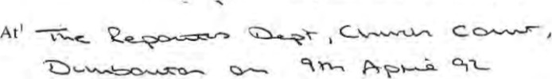
A children's hearing for Strathclyde Region, in exercise of the powers conferred by section
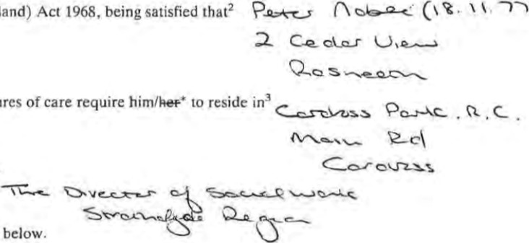
to be under the supervision of⁴
44(1)
of
the
Social
Work
(Scotland)
is
in
need
of
compulsory
measures
subject to the conditions noted below,
Chairman of the children 's hearing
CONDITIONS REFERRED TO IN THE FOREGOING SUPERVISION REQUIREMENT
tl. The child is required to observe the rules Of conduct of the residential establishment.
t2. The requirement to reside is subject to the discretion of the managers of the residential stablishment to grant leave of absence from time to time.
Chairman of the children's hearing
end date
2 Name gnd address Of enild t Where supervision requirement.
Deiete us *ppropttgte
WH&COLTD loa @
Form 14 Requirement under section 43(4) Of the Act.
Rule 26.

STRATHCLYDE REGIONAL COUNCIL
SOCIAL WORK (SCOTLAND) ACT 1968
THE CHILDREN'S HEARINGS (SCOTLAND) RULES 1986
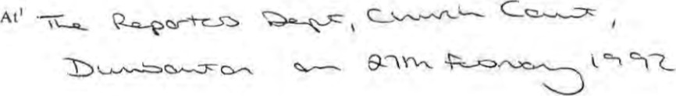
A children's hearing for Strathclyde Region, in exercise of the powers conferred on them by section 43(4) of the Social Work (Scotland) Act 1968, require ² 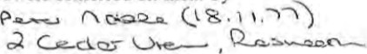a
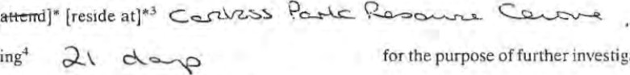
to during in relation to him/hpr* and his/ker• history.
investigation

Chairman Of the children's hearing
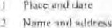
3 name Of
Insert timeor renod noi 2 ' dab uppnTtiOte
W H & CO


LLB
LLB
€82
Tel: (0389) 6426B | Fax: (0389) 42131 | Strathclyde
our Ref: ES/CM  Your Ref: |  | SCOTLAN D
Date: 2 March 1992 
Area Manager
Social Work Dept.
50—52 Sinclair Street

Helensburgh
Char Sir Ibadan,
Child's rare; Peter Noble (1B.11.77)

Address : 2 Cedar View, Rosneath

Hearing location: The Reporter' s Office, Church Court, Dumbarton
12 noon date: Thursday, 12 March 1992 Residential Establisyrrent; Blairvadach Children's Home, Shandon
Tae above named has today been forrrally cited co a Chil&en's Hearing for Strathclyde Region.
1 shall be obliged if you will liaise with the Head of the Residential Establishoent and ensure that the above naqed is conveyed to the Hearing at the tine and place specified above.
Thank vou.
Yours faithfully,
Mrs E'. Sheer
Assistant Area Reporter

LLB

I B
GB2
Teh (0389) 64268 Fax: (0389) 42131 Strathclyde
Our Ref: ES/LAMc1 SCOTLAN D
Your Ret:
Date: 17th February, 1992 A nuclear. tree zone authority An equal opportunities authority
The Area Manager Social Work Department
50—52 Sinclair Street
Hel ensburgh
Dear Sir /b%dam,
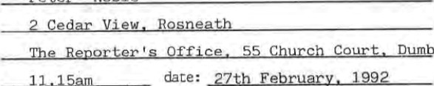
15aJ11
Child's
narrp:
peter
Noble
Address
:
Hearing
location:
tine:
arton
 | ai rvaaech Chi | HQme.
Residential Establishænt:

line above narred has today been forrtully cited to a Children's Hearing for Strathclyde Region.
I shall be obliged if you will liaise with the Head of che Residential Establishrrent and ensure that the above narred is conveyed to the Hearing at the tine and place specified above.
Thank you.
Yours faithfully,


Mrs E Sheer
Assistant Area Reporter

I i B
LLB GB2
To': (0389) 64268 | Fax: (0389) 42131 | Strathclyde
our ÉS/CM |  | SCOTLAN D
Your Ref:
Date: 27 March 1992 
Area Manager
Social Work Department
50—52 Sinclair Street
Helengburgh
Dear Sir
Child's nare: Peter Noble (18.11.77)

Address: 2 Cedar View, Rosneath

Hearing location : The Reporter's Office, Church Court, Dumbarton t ire: 11.00 a:m. date: Thursday, 9 April 1992

Residential Establishrent: Cardross Park Resource Centre Main Road Car dross
above tidied has today been forrtaLly cited to a Children 's Hearing for Strathclyde Region.
I shall be obliged if you will liaise v,rith the Head of Residential Establishænt aid ensure that the above na-red is conveyed to the Hearing at the tire and place specified above.
you.
Yours faithfully,

Mrs E. Sheer
Assistant Area Reporter

 SWD/19
TO
Frederick J. Kennedy, O.B.E., LL.B.

MEMORANDUM
From ...55.mu.rch..Q2urt,...DW1tnrton. To ...Area.Eagex.
Social Obrk Department
Subject: Reporters' Duties and Transmission of Information. etc. (Scotland) Rules 1971—
Rule
In accordance with instruction contained in Rule 6 of the above Statutory Instrument the decision(s) made by a Children's Hearing is/are• undernoted. Annexed herewith copy requirement where appropriate.
Date Of Hearing | Name; | Decision:
30.9.93 | Peter Noble | Supervision ccmtinued at Burnside Family (h-oup Hate.

4 October 1993 
for
•Delete as appropriate
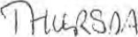
Form 12 Instrument continuing supervision requirement. Rule 24
30tu 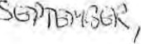I ^{C}IC3

STRATHCLYDE REGIONAL COUNCIL
SOCIAL WORK (SCOTLAND) ACT 1968
'I'HE CHILDREN'S HEARINGS (SCOTLAND) RULES 1986
At' SS CVlLRcq cowe- 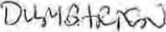
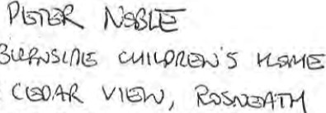
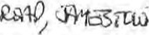
^{C}/o , 0.40109€0
Q
PIA
A children's hearing for Strathclyde Region, considering that the supervision requirement attached and docqueted With reference hereto is due to expire on2 (e 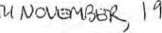q 70
and being satisfied that it is proper so to do, hereby continue the said requirement in force.
Chairman of the children's h/aring
date being from the Of the
W'frchever last cxcurred
W H & G—CP 12 @

 SWD/7
StrathcW&
TO
F. J. Kennedy, LL.B.

MEMORANDUM
From........ 55 .. Church...
50—52 Sinclair . %r.eet:
Subject: Reporter's Duties. etc. (Scotland) Rules 1971—Rule 5
NOTIFICATION OF HEARING
Herewith notification of a Hearing to be held on
at . 11.20 a.m. within .
The Reporter 's Office, Church Court.,. Dumbarton
A full list of those cited is undernoted, along with timing of each case.
Name | Time of Case | Reason for Appearance
J. Docherty Peter Noble (18.11.77)  600/91 2 Cedar View  Rosneath | 11.00 a.m. | continued hearing and groundS
27 "arch for
Form 4(A) Form of statement by reporter of grounds for the referral of a case to a children's hearing. Rules 16 and 17

STRATHCLYDE REGIONAL COUNCIL
SOCIAL WORK (SCOTLAND) ACT 1968
THE CHILDREN'S HEARINGS (SCOTLAND) RULES 1986
Peter Noble (18.11.77) 2 Cedar View
Rosneath
is being referred to a children's hearing for Strathclyde Region on the grounds of the following conditions²: in terms of Section 32 (2) (g) of the Social Work ( Scotland)
Act 196B, he has committed the Offences specified below.
STATEMENT OF FACTS
In gupport of the above condition, it is stated that:—
I. He did, between 20 and 21 February 1992 from outside the
Rosneath, steal a 'Ridgeback' mountain bike, the property of c/o The Reporter ^{i} s Office, Church Court, Dumbarton. This being an offence of Theft or alternatively
He did, between 20 and 21 February 1992, receive and retain a 'Ridgeback' mountain bike, the property of Stephen Lenton, c/o The Reporter's Office, Church Court, Dumbarton knowing it to have been dishonestly appropriated by theft.
This being an offence of Reset
2. He did, on 23 February 1992 at 2 Cedar View, Rosneath, whilst acting along with another steal a black jacket, the property of Melissa readhead, c/o The Reporter' s Office, Church Court, Dumbarton. This being an offence of Theft
3
SS Church Court, Dumbarton 64268
19 92 for Reporter
NOTES
At the children's hearing the child or his parents may or may not accept the gioundsfor bringing the child before the hearing. If the grounds are accepted by the child, and his parents, if present. the children's hearing will discuss and consider with the child and his parents what is best for the child. If any Of the grounds are not accepted, the hearing may either discharge the referral or direct the reporter to apply to the sheriff for a decision as to whether or not any of the grounds exist. If this happens the child will have to appear before the sheriffat a later daLC. If the sheriff decides that any of the grounds do exist. the children's hearing wit! then discuss and consider what is best for the child. as if these grounds had been accepted. If the sheriff decides that no grounds exist the referral will be discharged.
address chi Specify 3 Address0 Reporter
W H & COLTDG—CP4a @

 SWD/7
TO
F. J. Kennedy. LL.B
MEMORANDUM
To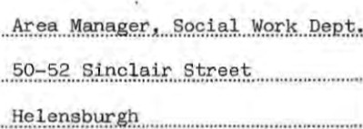

Subject: Reporter's Duties. etc. (Scotland) Rules 1971—Rule 5
NOTIFICATION OF HEARING
Herewith notification of a Hearing to be held on ..
12 noon
at . within
The Reporter's Office, Churc9 Cpur!2 pumPQE.tpp.
A full list of those cited is undernoted, along with timing of each case.
Name | Time of Case | Reason for Appearance
600/91 Peter Noble (18.11.77) | 12 noon | continued hearing
2 Cedar View
Rosneath
Social Workers J. Docherty
......„.
for


SWD/7
Regional Council

DEPARTMENT OF REPORTER TO THE CHILDREN'S PANEL
Reporter:
F. J. Kennedy, LLB.

MEMORANDUM
The Reporter ' s Office The Area Manager, Social
From........„....
55 Church Court Work Department, 50—52
Dumbarton Sinclair Street, Helensburgh
Subject: Reporter's Duties, etc. (Scotland) Rules 1971—Rule 5
NOTIFICATION OF HEARING
Thursday 27th February „ 1992
Herewith notification of a Hearing to be held on ...
The Reporter's Office ,
at
55 Church Court, Dumbarton

A full list of those cited is undernoted, along with timing of each case.
Name | Time of Case | Reason forAppearance
Peter Boble (18.11.77) | 11.15am
2 Cedar View
Rosneath

Date 17th Febryary.t.., for Reporter
NEA/ 1

STRATHCLYDE REGIONAL COUNCIL
Divisional/ Area Office:
our Ref .JH/CM
55 Church court
Dumbarton
Divisional Reporter: | 8 April 1994
Mr N. Macleod | Tel. 64268
Dear Sir/Madam
Re: peter Noble (18.11 .77), 2 Cedar View, Rosneath
The above named child has been referred to me in terms of Section 32 of the social work (Scotland) Act i 968, in connection 9.'ith an alJegatxon as undernoted.
After a full investigation of all the facts and careful consideration of the circumstances, I have decided on this occasion that no further action will be taken on this matter.
Yours faithfully
for Reporter
NOTE:
Breach of the Peace

Area Manager
Social Work Department
50 Sinclair Street
Helensburgh


Regional Council
Department of Reporter to the Children's Panel
Region Reporter: Frederick J Kennedy OBE LLB
Argyll, Bute and Dunbarton Division
Divisional Reporter: N Macleod I I
55 Church Court, Dumbarton GB2 ISU
Tel: (03E9) 64268 | Fax: (0389) 42131 | Strathclyde
our Ref: ES/CM |  | SCOTLAND
Your Ref:
Date. 9 March 1992
J Docherty 
Social Work Department
50—52 Sinclair Street He lensburgh
Dear Mr Docherty

Re: Peter: Noble
I refer to the notification for a Children's hearing on Thursday, 12 March 1992 at 12 noon regarding the above named child.
The merely to check the progress or otherwise Of the assessment and given peter has now been admitted to Cardross, this is no longer necessary
The hearing has therefore been cancelled and you will be notofied in due course of further hear ings once the assessment is complete.
Yours sincerely
Mrs E. Sheer
Assistant Area Reporter
Form 14 Requirement under section 43(4) of the Act. Rule 26.

STRATHCLYDE REGIONAL COUNCIL
SOCIAL WORK (SCOTLAND) Acr 1968
THE CHILDREN'S HEARINGS (SCOTLAND) RULES 1986
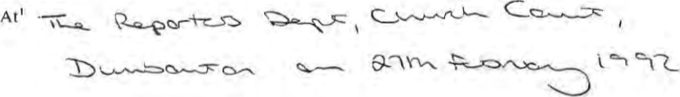
A children's hearing for Strathclyde Region, in exercise Of the powers conferred on them by section 43(4) of the Social Work (Scotland) Act 1968, require²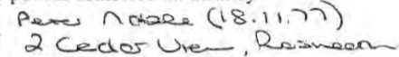
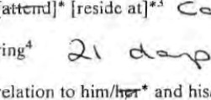
to C eaS-rz„ZS
during4
in
relation
to
for the purpose of further investigation and his/her* history.

Chainnan Of the children 's hearing
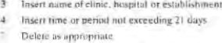
and dare
y
Name and adOVe•.s
W H CO LTD G—-CP

NFA/I

Regional Council
Divisional Reporter:  N. Macleod | 64268
DEPARTMENT OF REPORTER TO THE CHILDREN'S PANEL
Reporter: | Your Ref. |  | Divisional/Ärea Office:
F, J. Kennedy, LL.B. | our Rec | ES/JK | Church Court,  Dumbarton

Dear | 4th June, 1992
Sir,
Social Work (Scotland) Act 1968
Peter Noble, 2 Cedar View, Rosneath has been reported to me in terms of Section 32 of the above Act, in connection with an allegation as undernoted.
After a full investigation of atl the facts and careful consideration of the circumstances, I have decided on this occasion that no further action will be taken on this matter.
Yoere
for Reporter
Note:
Theft and Contravention of the Sexual Offences (Scotland) Act 1976
The Area Manager ,
Social Work Department, 50—52 Sinclair Street Hel ensburgh.
WB634
 sw (5
Strathclyde
DEPARTMENT OF REPORTER TO THE CHILDREN'S PANEL
Reporter:
F. J. Kennedy, LL.B.

MEMORANDUM
Church
50—52 Sinclair Street
.
Subject: Request for Social Background/SuppIementary Report(s)
Social is"æc required in respect of the undernoted, in terms of the Grounds indicated,
10 February 1992
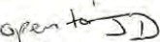
Please submit not later than ..............„................
Name, Address & dab. SchoolA ttended Grounds
peter Noble (18.11.77) Hermitage Academy Theft by Housebreaking
I Residential Site
Rosneath Caravan Site
Rogneath
600/91
Further information may be obtained from this office.
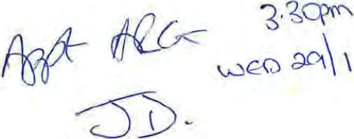
ror neporter
•Delete as appropriate

Form A) Forni of statenren,' by reporter of grounds for the referral ofa case to a children •s hearing. Rules 16 and 17

STRATHCLYDE REGIONAL COUNCIL
SOCIAL WORK (SCOTLAND) ACT 1968
THE CHILDREN'S HEARINGS (SCOTLAND) RULES 1986
NOBLE; Peter (18.11.77)
2 Cedar View, Rosneath
is being referred to a children's hearung for Strathclyde Region on the grounds of the following
conditions 2..
in terms of Section 32 (2) (f) of the Social Work (Scotland) Act 1968, he has failed to attend school regularly, wi thout reasonable excuse, as specified below.
STATEMENT OF FACTS
In support of the above condi tion, it is stated that the said Peter N%le was born, so far as hag been ascertained on 18-11.77 and is and was, at all material times, a child of school age .
That he is and was, at all material times, a pupil enrolled iffknnitage under the management of Strathclyde Regional
Education Department.
That he failed to attend school on various occasions between hd Decarber, 1991 and 10th January, 1992
That during that period his absenceg from school amounted to 37 half days, out of a total of 40 half days, within that period, during which he was required to attend the school .
That he had no reasonable excuse for all these absences.
Church Court, Dumbarton - 64268
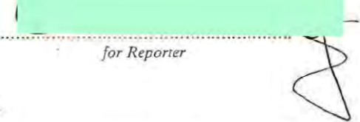
17th February, . 19 92
NOTES
AK the children's hearing the child or his pareni5 may or may not accept the grounds for bringing the child before the hearing If the grounds are accepted by the child. and his parents. if present, the chiidren•s hearing will discuss and consider with the child and his parents what is best the child. If any of the grounds are not accepted. the hearing rnäy either discharge the referral Or direct the reporter apply 10 the sheriff ior a dcctsion as to whether or not any of the grounds exist* If this happens the child wÆll have to appear before the sheriff at a later date. If the sheriff decides that any of the grounds du exist. then discus; these gtounds had been accepted. If the sheriff decides that no grounds ex;s'. the referral will be discharged.
Nume and 2 SpecifyAddass

• co @
Form 4(A) Form of statement by reporter of grounds for the referral of a case to a children's hearing. Rules 16 and 17

STRATHCLYDE REGIONAL COUNCIL
SOCIAL WORK (SCOTLAND) ACT 1968
THE CHILDREN'S HEARINGS (SCOTLAND) BULES 1986
FOBLE: Peter (13.11.77)
2 Cedar View, Rc:sneath is being referred to a children's hearing for Strathclyde Region on the grounds of the following
conditions² .• in tÄTrs Of 32(2) (g) of •the Social Work (Scotland) Act, 1968, he
has carrnitted the offences, as specified below.
STA'1E,ß.rr (F FACIS
In suport of cmditicn, it is stated that —
- did, vhile acti.rv almg with offpr 25th a-rd 26th 1991, break into the (ive11iæ house at I HiÜi Barrack Farm, Rcsneath, in District of nnbarta•i, steal the sun of c.a±, the prcperty
This being an offmce of 'Iheft by
- I-E did, 2,4frJ Jaruazy, *Lile acting along with other travel m the rai-lv.ay between Glægoe.' and vdlhout having previ(lsly paid his fare and With intent avoid tiereof. 'IHis offer-jce of Ccntx•aventicn of the Regalat;icra of Rai.lvgws Act, 1839, Sectim 53(a) as a-rmded.
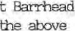
- did, 24th Jaruatv, 1992, acting along arn%er per-scn, at Rail'.qy Staticn, been arrested for camitting offa-)ce by Police Const3b1es Scott YEKechnie 191 and Alexmder Ehrv.ood 2018, both British fra-spor•t Eblice, resist such, LawfUI arrest by struæling viola-ltly, breaking free md rtrning off. ^{f}lhis being an offence of Cctfraventim of the Preventim
3 of Act, 1953 Sectim I(a)
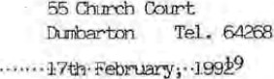
for Reporter 
NOTES
At the children's hearing the child or his parents may or may not accept the grounds for bringing the child before the hearing. If the grounds are accepted by the child. and his parents. if present, the children's hearing will discuss and consider with the child and his parents what is best for the child. If any of the grounds are not accepted. the hearing may either discharge the referral or direct the reporter to apply to the sheriff for a decision as to whether or not any of the grounds exist. If this happens the child will have to appear before the sheriff at a later date- If the sheriff decides that any of the grounds do exist. the children•s hearing then discuss and consider what is best for the child, as if these grounds had been accepted. If the sheriff decides that no grounds exist the referral Will be discharged.
and address Of child 2 'Soeeity Condi"onsn
CO
Form 13 Instrument terminating supervision requirement. Rule 24

STRATHCLYDE REGIONAL COUNCIL
SOCIAL WORK (SCOTLAND) ACT 1968
THE CHILDREN'S HEARINGS (SCOTLAND) RULES 1986
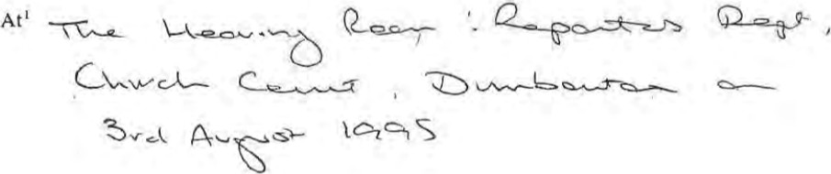
A children's hearing for Strathclyde Region hereby terminate the supervision requirement
attached and docqueted with reference hereto as from²
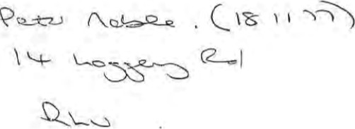

Chairman Of the children's hearing
Place date
Date which termination is (o effect
CO C

NAME: Noble-
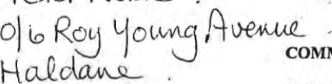COMMUNITY CARE GRANT AWARD
10)
SECTION 29 AWARD Sco
TOTAL 500
RECEIPT NUMBER |  |  |  | GOODS  PURCHASED |  |  |  |  | AMOUNT SPENT |  |  |  | BALANCE
 |  |  |  |  |  |  |  |  | 35.
 |  |  |  | 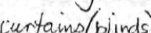 |  |  |  |  |  |  |  |  | , 20
 |  |  |  |  |  | 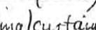 |  |  |  |  |  |  | 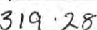
 |  |  |  |  |  | 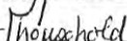 |  |  |  | 2
 |  |  |  | 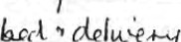
 |  |  |  | 
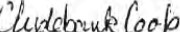
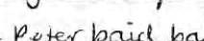 |  |  |  |  |  |  |  | 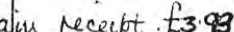
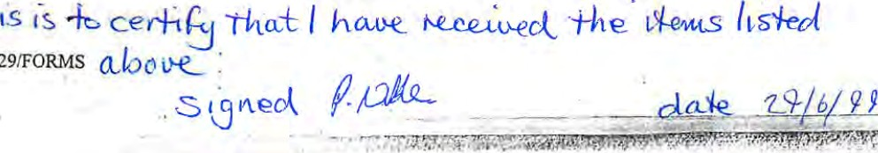
SEC29/FORMS
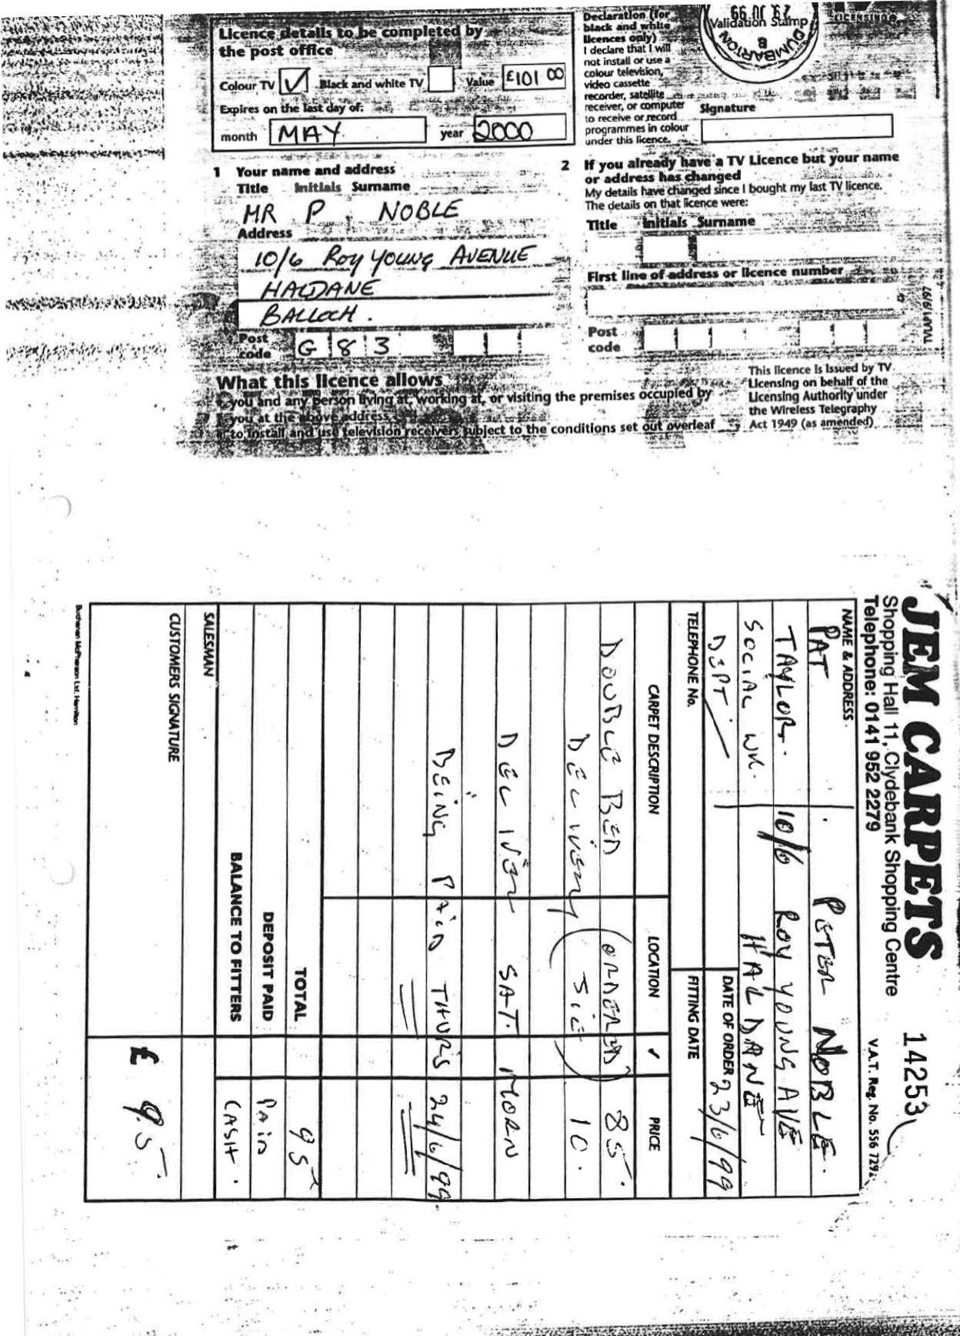
 | 'CO  「  I+ECT•ION  •POINV  22 |  | 10T  一 · 一  1  , 一  •  5 t10.00 104.21  ,  79 |  | TAIN  TRACK | 1 15 闺  2041  ;  ET Fi  24 17 | 一二  -  SOI?DI一  (m3287  1  WILTDB2  P |  | Tel  11n7
 |  |  | ·  4』2 | ESR-EY~S  YELLM8LI ES  LTD  CLYDEBANK  了· 0141-952一0 、VAT · 259 6 4 10 吅呎RECEIPT  THANK %-'üLI | 501  19 袃  一  T  一一  9.93
 |  |  |  |  |  | ROLLER KIT  , B80HVNEX02.5  DULUX PAI盯  POLY ,0/S  TO勰 |  | 2629  1 39
TOCK 0、
E
RYCANO :
一 4
,
232
RESERVAVOH 19
、
、
SERVICE 一
:
.lydd;nk
心
• 29/06/99 15:  •: 80D2 44 | 01一! | Vou bf
L | |  | 19 06, 13: 18 0】3 111一732  ,
 | IQ | THANK YOU「0 PING AT B&O

T 13 · 00

• CHANGE

TEL 0141 9 1 ~ •「X 0141 491 4
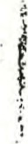
. = wg501.
SURNAME   | Forenames |  |  | Date of Birth |  | Reli ion |  | Marital Status
 | 
ADDRESS 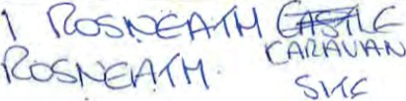  POST CODE  TEL. NO. |  |  |  |  | CHANGE OF ADDRESS
 |  |  |  |  | OCCUPATION/SCHOOL
NEXT OF KIN |  |  | G.P. NAME AND ADDRESS  TEL NO.
REFERRED BY |  |  |  | REASON(S) FOR ALLOCATION (Including appropriate legislation and accommodation if moved from own home)
REASON(S) FOR REFERRAL
HOUSEHOLD COMPOSITION (Numbers of members: Relationship to case
NAME |  | Relationship | Age | Name(s) of other relevant persons |  |  | Address
OTHER AGENCIES INVOLVED
NAME ADDRESS TEL. NO.
(1 )
(2)

OTHER RELEVANT'SIGNIFICANT INFORMATION AND CHANGES (e.g. Financial. Housing situation)

Name of Child: | Peter Noble
Date of Birth: | 18.11.77.
Name of Home: | Blairvaddach
Date of admission: 25.1.92.
Summary of decisions from last review (if appropriate):
I. Legal Position/Section under which child is in care:
Section 15 Social Work Scotland Act
Any action indicated:

2. Current address/es of:
(a) Parents:
c/o Henry, 2 Cedar View Rosneath ( YSibIings not in care:
(c) Siblings in care:

3. Present situation with family since reception into care/last review:

-wag Continued

Form D continued (2 of 3)
- Date/s and nature of Social Worker's contact with child since reception into care/last review:
One meeting I. T. One home visit.

- Date/s and nature of Social Worker's contact with family since reception into care/last review:

- Areas of Concern:
- Family Relationship with parent.
- Particular reference to child in care (including progress since reception into care/last review.)

'Z. Other agencies involved:
p •chological Services Hermi tage Academy

8. Needs of the child (estimated length of placement, type of placement, involvement of other agencies, estimated nature of parental contact etc.):
- Need to set up regular contact between child and parent.
- Early return to school essential .
- Panel to be organised by end of February 1992.

Continued
- Plans for child in view of above comment (including short, medium and long objectives):
Short term objectives — I. To return Peter to school.
  - To complete period of assessment whilst in Blairvadach.
  - Possibility of assessment in Cardross.
9(a) Is an application for Assumption Of Parental Rights appropriate? WNO

- Any further comments:

Il. Persons who will atttend review (from area team):
Area Manager David Burke. Social Worker — Joseph Docherty.
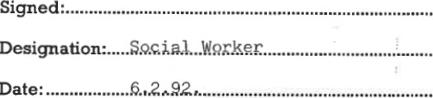


Strathclyde
Regional

Council
Name of Child: | Peter Noble
Date of Birth: | 18 11 77
Name of Home: | Cardrogg Child Resource Centre
Date of admission: | 6 3 92

Summary of decisions from last review (if appropriate):
To return Peter to school
To explore possibilities of cornmunity parents

I. Legal Position/Sec!ion under which child is in care;
Any action indicated:

2. Current address/es of:
Parents: 2 Cedar View Rosneath
- Siblings not in care:
- Siblings in care:

- Present situation with family since reception into care/last review:
Peter has had virtually no contact with his father and limited contact with his mother since reception into care.

- Date/s and nature of Social Worker's contact with child since reception into care/last review:
IT Group dates Feb 25, March 3, March 10, March 17
9 April | Childreng Hearing
14 May | Assessment Review
1B May | Meeting at Cardross
29 May
12 June

29 June
6 Aug

- Date/s and nature of Social Worker's contact with family since reception into care/last review:
No face to face contact
Letter sent 9 9 92 urging attendance at review

- Areas of Concern:

(a) Family
(b) Particular reference to child in care (including progress since reception into care/last review.)
Peter has settled well in. Cardrosg and now attends Our Lady and St Patricks High School. Keyworker reports he iB becoming increasingly dissatisfied with 1 Ivlng in Cardrosg.

7, Other agencies involved:
4)
YPIT Project
School Guidance
Family Finding

8. Needs of the child (estimated length of placement, type of placement, involvement of other agencies, estimated nature of parental contact etc.):
Peter has expressed a desire to live with a family and begin a new life. In the meantime he feels things are not moving fast enough and has put forward the idea of moving to a childrens home .

Continued
•9. Plans for child in view of above comment (including short, medium and long objectives):
Short term objectives include Peter developing the responsibility to attend school and receive an education. It is imperative that a family be found for him as goon as possible to support him and continue the progress he has made in this area.
Longer term plang are centred on peter becoming a member of a family and developing relationships within it.
10. Any further comments:

Il. Persons who will atttend review (from area team):
David Burke Area Manager
Joe Docherty Social Worker

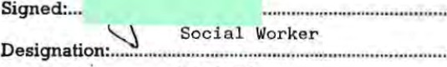
23 9 92
Date:


Strathclyde

Regional Council


swD/19
Reporters' Duties and Transmission of Information, etc. (Scotland) Rules 1971 Rule

STRATHCLYDE REGIONAL COUNCIL
DEPARTMENT OF REPORTER TO THE CHILDREN'S PANEL

Reporter. F. J. KENNEDY OBE LL.B
MEMORANDUM
From: Reporters Department To: Social Work Department 55 Church Court 50 Sinclair Street, Helensburgh
DUMBARTON G82 ISU
SUBJECT: REPORTERS' DUTIES AND TRANSMISSION OF INFORMATION, ETC (SCOTLAND)
RULES 1971 - RULE
In accordance with instruction contained in Rule 6 of the above Statutory Instrument the decision(s) made by a Children's Hearing are undemoted.
Annexed herewith copy requirement where appropriate.
Date of Hearing: 7th September, 1994

Name: | Details of result:
Peter Noble | Residential Supervision Requirement varied to Non Residential Supervision Requirement.


Date: 13/09/94 | for Reporter

CPArea 12 13/09/94
Form Il(A) Supervision requirement varytng existing supervision requirement Rule 24

STRATHCLYDE REGIONAL COUNCIL
SOCIAL WORK (SCOTLAND) ACT 1968
THE CHILDREN'S HEARINGS (SCOTLAND) RULES 1986
Atl 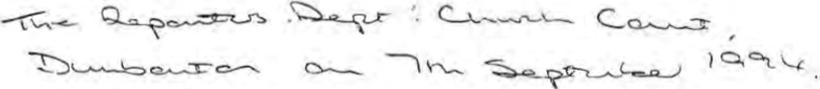
A children's hearing for Strathciyde Region by way of variation of [and in substitution for] *
to 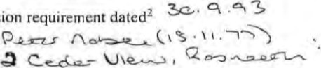which³ is subject, hereby require him/her* [to-reside-ir+
the
supervision
[to be under the supervision of
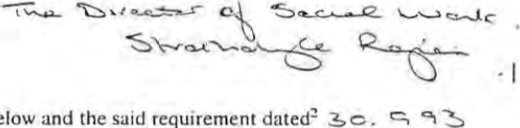
subject to the conditions noted below and the said requirement dated is herby revoked.
Chairman of the children's hearing
CONDITIONS REFERRED TO IN THE FOREGOING SUPERVISION REQUIREMENT
t l. The e Lld is required o obse the rules of conduct of-the residentia tablishment.
t2. The requirement to reside is s bject to the discretion Of the managers enti I establishment to grant leave of bsence time to time.
3, etc.

Chairman of the children's hearing
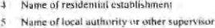
date
0'
2 Date previous supervision merit
NameOf child
- Where supervision requirement requites child '0 reside in residential establishment. conditions and 2 Shuu Be inserlcd in supc'visivn
tement.
- Delete appropriate
W H & CO LTDG—CP lla
9 : 74 ТО paGE , ваемва:з
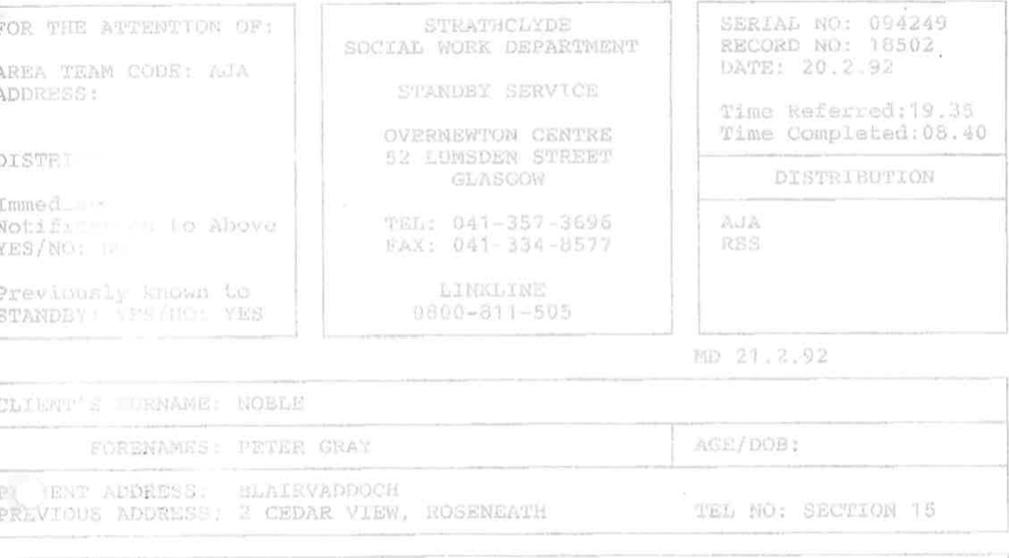
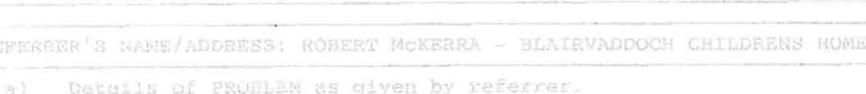
- .
- .
ALERT ORM Serial No.  Date Received  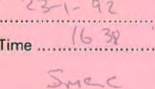  Time |   STAND-BY SERVICE  OVERNEWTON CENTRE  52 LUMSDEN STREET  GLASGOW  Telephone 041857 3696  Fax: 041-334 8577/041-339 2899 | 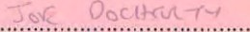  From  Social Worker .    Area Team........... .  Address....
 |  | Telephone............... ..
 |  | District

eQ -rrcR Client's SurnameForenames
Present Address .... Age/DOB .
Previous Address .Telephone .
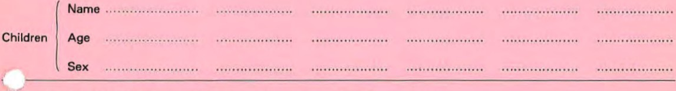
KEY PERSONS INVOLVED, e.g. G.P.s, Caring Relatives, Other Agencies, Etc.
Name | Relationship/Occupation | Address | Telephone
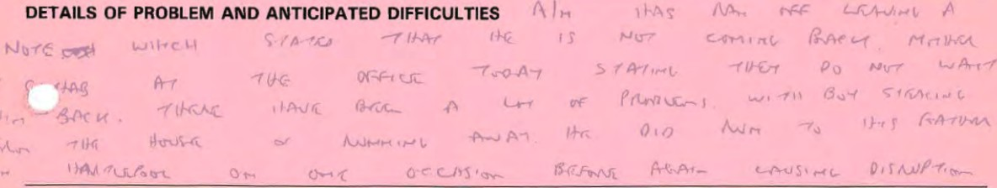
CARING ARRANGEMENTS-ALREADY-MADE ^{D}BYAREATEAMANCLUDING THOSE IN ANTICIPATION^{Ø}OF EMERGENCY
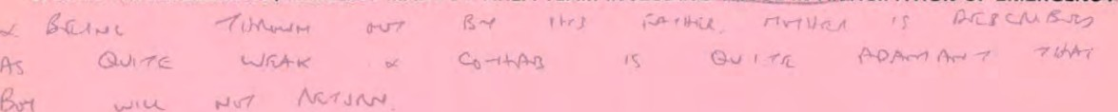

ACTION REQUESTED OF STAND-BY STAFF IN EVENT OF EMERGENCY

WIS
SUPPLEMENTARY INFORMATION
RE PETER NOBLE
Please find enclosed information on Peter Noble who has been referred to you from Dumbarton District.
Peter continues to reside in Burnside Children's Home awaiting placement with yourselves. He continues to refuse to attend school despite considerable support from guidance staff. In Burnside, whilst he is not regarded as a management problem staff are concerned over his lack of education and life outwith the home.
He has recently been involved in the purchase and use of cannabis and has encouraged other children there to use it. Staff have also found Peter to be less than truthful in his responses to questions asking about where he spends his time outwith the home.
At the last child care review a decision was taken to seek a place at Gielsland School and following referral to DASU on 26th April I now write to request that consideration be given to Peter for a place with you.
I will be more than happy to supply you with any additional information you may require.
JOSEPH DOCHERTY
Social Worker
19 May 1993
RPNJD

ARGYLL/BUIT/DUFBAR'IÜN(CLYDEBANK SUPmRTED ACCCMDDATION TEAM

REFERRAL FORM
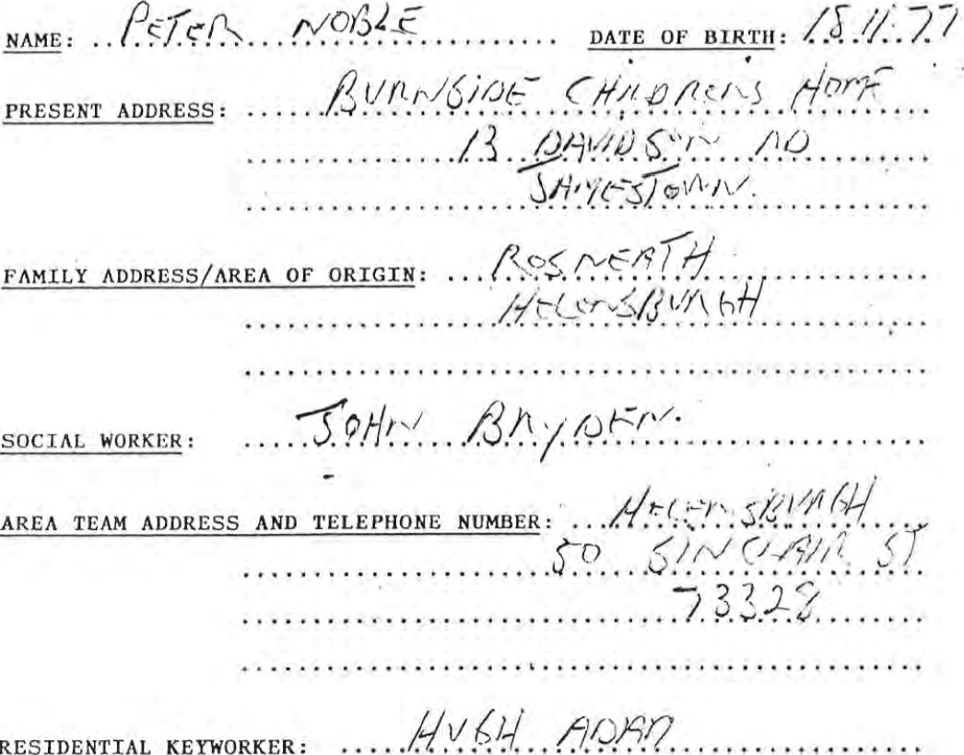
SECTION
1
HEALTH: (please comment on general health, any significant medical hist,ory
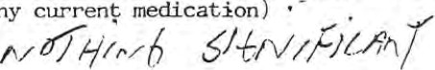
and
any
S.A.T. Form
SECTION 2
- Please give a brief indication of social skills (e.g. ability to communicate effectively, ability to form relationships, degree of 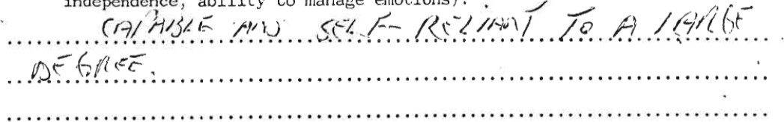independence, ability to manage emotions) :

- PI ease i ve details Of ractical skills and de ree of com etence
e.g. cooking, personal hygiene, managing finance and understanding of benefit system) It would be helpful if areas of competence and those areas where work required could be identified in conjunction with the young
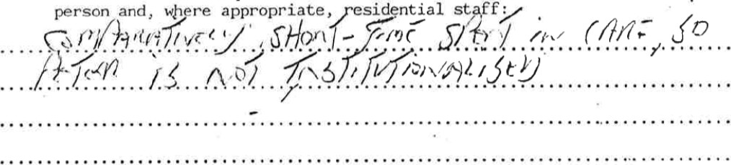

- Assessment of young person s needs — which option is felt to be the most appropriate at this time?

i) Hill park
Supported lodgings
Group Tenancy iv) Joint Tenancy
    - Sole Tenancy
    - Other teo-
S.A.
- Area of Preference

Argy 11
But e

iii) Clydebank
Dumbarton
Hardgate/Faif1ey

Helensburgh
Vale of Leven viii ) Other
(e) Short and long—term plans for young person and level of support required:
i) from area team social worker:
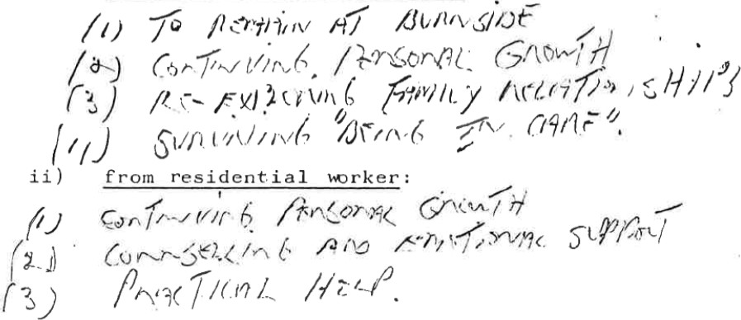
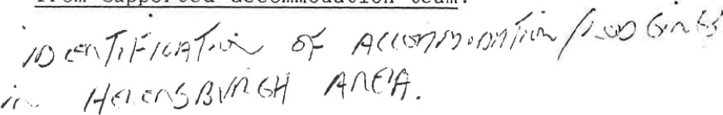
iii) from supported accommodation team:
S.A. T. Form 1
SECTION 3
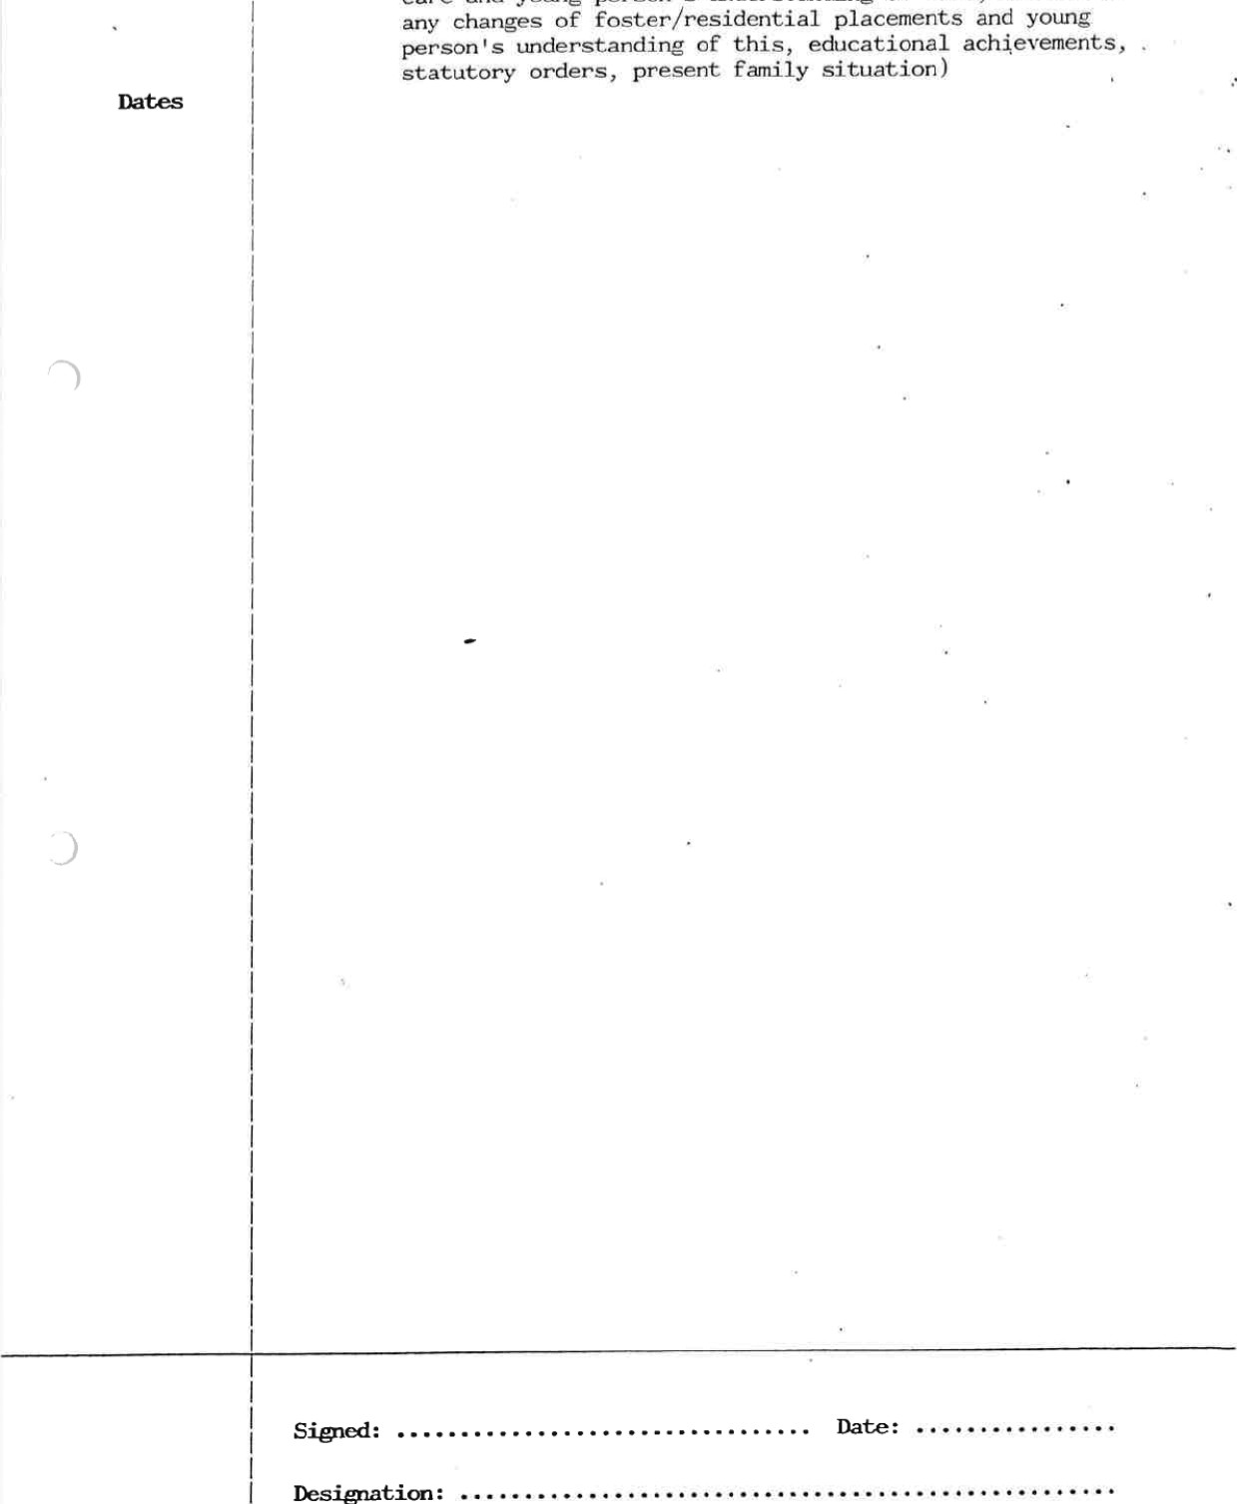
FERSONAL HISTORY: (to include. relevant dates, reasons for reception into care and young person 's understanding of this, details of any changes of foster/residential placements and young person 's understanding of this, educational achievements, statutory orders, present family situation)

S.A.T. Form


Strathclyde Regional Council Social Work Department
McLean Place,
Dumbarton,

G82 1
Director: Miss Mary C Hartnoll, CBE, BA
Telephone No: 0389 63437/61626 | Strathclyde
our Ref: IV/DP  Your Ref: | SCOTLAND
Date: 11 May 1994 A nuclear-
If calling or phoning please ask for: Mrs vasile free zone
authority An equal opportunities authority
Supported Accommodation Review Report

peter Noble. 18.11.77). Burnside. 13 Davidson Road. Jamestown. Alexandriq.
Since my initial meeting with Peter on 9th February 1994, I have continued to have contact with him on a two/three weekly basis.
Our meetings have so far taken place within Burnside and included a joint meeting with Hugh Adam on 8 March 1994. Following my initial introduction Peter completed a leaving care questionnaire to highlight the issues he felt were relevant to him during his oreparation for leaving care. We have started to work through the issues and so far we have discussed the following:-
Leaving care on a planned/unplanned basis;
Coping with change (past and present);
Career/job prospects;
Accommodation options;
We have also started to use worksheets relating to a range of feelings/emotions.
Peter has kept all appointments and out discussions have been very productive with him participating well. The discussions have mainly focused around Peter's intention to enlist in the army this summer. However, I will continue to offer support and advice to Peter during the time he remains in Burnside.

Iris Vasile
Support Worker

Mr M Rodden
Senior Social Worker

RIC5B
Social Work Department
Strathclyde

Discharge Form
FOR CHILD IN CARE
NOTE—THIS FORM IS NOT TO BE COMPLETED FOR CHILDREN WHOSE ONLY
STATUTE IS SECTION 44M SUPERVISION—SOCIAL WORK (SCOTLAND) ACT 1968 OR SECTION 12 MATRIMONIAL PROCEEDINGS ACT 1958.
AREA TEAM
UNIQUE NUMBER OF CHILD
NAME OF CHILD
DATE OF BIRTH
DATE OF DISCHARGE
DATE ADMITTED TO
PRESENT PERIOD OF CARE
SEX Male Female
B ACCOMMODATION Please Placement give and Name tick and the Address appropriate of box.
PLACEMENT DISCHARGED FROM

COSTERING WITH RELATIVES | CHILDREN'S HOME
01 Temporary | 06 Local Authority
Cl 02 Permanent | C] 07 Vüntary
FOSTERING UNRELATED | a 08 UST D'
C] 03 Temporary | a 09 SECURE ACCOMMODATION
04 Permanent 10 LIST G
Cl 05 COMMUNITY PARENTS ASSESSMENT CENTRE
12 HOSPITAL AT HOME
CASE FILE

E LEGISLATION DISCHARGED UNDER
Main Secondary
- Section 15 Social Work (Scotland) Act 1968
- Section 16 Social Work (Scotland) Act 1 968
- Section 37 Social Work (Scotland) Act 1968
- Section 40 Social Work (Scotland) Act 1968
- Section 44(1 Ha) Social Work (Scotland) Act 1968 with Condition of Residence
- Section 44(1 Ha) Social Work (Scotland) Act 1968 Home Supervision
- Section 44(1 Social Work (Scotland)
Act 1968
- Section 58(a) Social Work (Scotland) Act 1968
(as amended by HASSASSA Act
1983 sec 8(4))
- Section 42(3) social work (Scotland)
Act 1968
- Section 4314) Social Work (Scotland) Act 1968
- Section Procedures
(Scotland) Act 1975 + 406
- Section 323 Criminal Procedures
(Scotland) Act 1975
- Section 206/413 Criminal Procedures
(Scotland) Act 1975
- Section 12(5) Foster Children
(Scotland) Act 1984
- Section 26(1 Adoption Act 1978
- Section 10 Matrimonial Proceedings
(Children) Act 1958
- Section 12 Matrimonial Proceedings
(Children) Act 1958
- Section 7 Children Act 1958
- Section 1 Guardianship Act 1973
- Section 24 Social Work (Scotland) Act 1968
- Other (Please Specify)
F To DISTRICT OFFICE FINANCIAL PAYMENT INVOLVED? YES/NO.
If Sect. B for details)
ANY SPECIAL INSTRUCTIONS

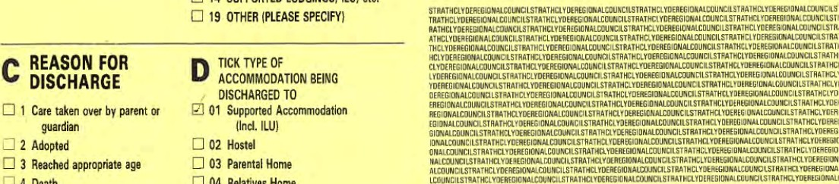
C] 14 SUPPORTED LODGINGS, ILU, etc C] 19 OTHER (PLEASE SPECIFY)
C
REASON FOR D TICK TYPE OF
DISCHARGE ACCOMMODATION BEING
DISCHARGED TO
C] 1 Care taken over by parent or Supported Accommodation guardian (Incl. ILO)
Z] 2 Adopted 02 Hostel
C] 3 Reached appropriate age Parental Home
C] 04 Relatives Home
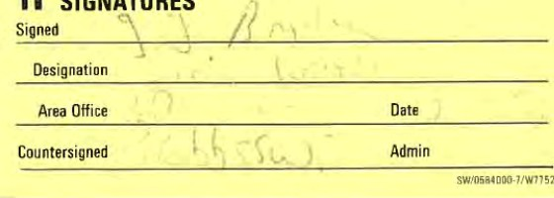
5 Decision Of hearingFlat/Bedsit/Digs H SIGNATURES
6 Other (Specify) 06 Living in at Work
Homeless Accommodation indufig Bed and Breakfast
Z] 08 Other (Please specify)
C] 09 Unknown
Summary of decisions from last review (if appropriate):
I. Placement to continue — 44 1 (b), Social Work (Scotland) Act
- Plan to attempt to deal with charge of Breach of the Peace via Panel system.
- Employment — John/Hugh to discuss option of full time CSV placement at present. 4. Weekly contact with mother to continue.
- Overnight stays at girlfriends parente to be negotiated by Peter via John/peter as appropriate
- John/ Hugh to discuss/explore potential for re—establishing contact between Peter and father .
- John Bryden to make referral to Supported Accommodation Team.

l. Legal Position/Section under which child is in care;
Section 44 1 (b) Social Work Scotland Act.
Last Children's Hearing on 30.9.93. Any action indicated:

Name of Child: | Peter Noble
Date of Birth: | 18.11.77
Name Of Home: | Burngide Children ' G Home
Date of admission: | 25-1.92
2. Current address/es of:
- Parents:
- Siblings not in care:
- Siblings in care:

- Present situation with family since reception into care/last review:
Although Peter has keot regular contact With his mum I have not seen her myself. Occasi onal Iy 'visits Burnside to collect Peter.

Continued

- Date/s and nature of Social Worker's contact with child since reception into care/last review:
ID, 1.94 — Office visit 25.3.94 Home viBit
12.1.94 — Office visit 11.4.94 — Home visit
11.2.94 — Office visit 21.4.93 — Home visit
14.2.94 — Office vigit S. 5.94 — Home visit
19.2.94 — Office visit
9.3.94 — Home visit
16.3.94 — Home viSit

- Date/s and nature of Social Worker's contact with family since reception into care/last review:
None
6.
Areas
of
Concern:
- Family
- Particular reference to child in care (including progress since reception into care/last review.)
Reaching decisions about Joining the Army or actively pursuing alternatives.

- Other agencies involved:
CSV — Give and Take Scheme, Glasgow
Last progress meeting occurred on 16.3.94

- Needs of the child (estimated length ot placement, type of placement, involvement of other agencies, estimated nature of parental contact etc.):
It is Peter's wish to remain in Burnside unless suitable accommodation becomes available through the efforts of SAT in Helensburgh area. Alternatively, if Peter joins the Army we need to consider where he would go for home leave.

Continued
- Plans for child in view Of above comment (including short, medium and long objectives):
Peter ^{i} s commi ttrnent to his CSV placement at Jamestown Nursery is drawing to a natural conclusion and should not extend beyond June. This respregent3 a considerable personal achievement which deserves to be acknowledged.
Basically we need to support Peter in practical and financial ways to achieve his ambitions over the next year. At an emotional level he seems increasingly self reliant and his relationships With staff from the Department reflect this.
Should Peter decide against the Army, we require to try and co—ordinate his place of residence With his employment opportunities ie accelerate move to Helengburgh if possible.
9(a) Is an application for Assumption of Parental Rights appropriate? Yes/No

- Any further comments:
Peter recently spend a week at an Army introductory course in Penicuik which wag arranged through the auspices of the Careers Service. He enjoyed this and thig seems to have confirmed his interest in an Army Career.
James Robb, Senior Social Worker
John Bryden, Social Worker
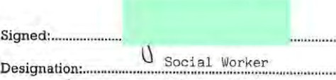
5th may 1994
Date:


Strathclyde
Regional
Council
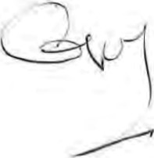
  Argyll +Bute
  COUNCIL
Argyll and Bute Council
Comhairlc Earra Ghåidheal agus Bhöid
Housing and Social Work Department
Director: Douglas Hendry

29 Lomond Street. Helensburgh. G84 'PW
Telephone: (01436) 638750 Our Rd: JWNAT Your Ref:
Date: APRIL 1999 phoning or calling please ask for: JAMES ROBB
Cal Duffy
Who Cares? - Scotland
Block 4, Unit C3
Templeton Business Centre
62 Templeton Street
Glasgow
G40 IDA
Dear Sir/Madam,
Re: Peter Noble - Section 29 Reque!
In response to your letter of 6th April 1999
I have noted the information that you have provided though it does not all coincide with our records of the case. Given this, I repeat the offer given to Pat Taylor, by both myself and John Bryden, that John would be happy to meet with herself and Peter to discuss the matter in greater detail and thereafter a recommendation be presented to myself
To date this matter has been dealt with via telephone calls and written correspondence which I do not believe has been particularly helpful in creating a detailed dialogue. I am quite happy to look at any case in these circumstances but I must insist that my staff, John Bryden in this case, must be convinced that it is appropriate.
I would hope that Pat and Peter would contact John to instigate a proper meeting in the near future in order that this matter can be concluded.
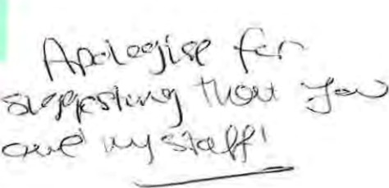

Yours faithfully
James D M Robb
SERVICE MANAGER


NATIONAL OFFICE:

BLOCK 4 UNIT g TEMPLETON BUSINESS CENTRE

62 TEMPLETON STREET
GLASGOW G40 IPA
TEL: 0141 554-4452 FAX: 0141 550-3834
PLEASE REPLY TO:
6th April 1999
Jim Robb
Service Manager for Helensburgh & Lomond
Social Work Department
29 Lomond Street
Helensburgh G84 7PW
Dear Mr Robb
I am writing on behalf of Peter Noble, resident at 10/6 Roy Young Avenue, Haldane,
Dunbartonshire, (from 12th April 1999) to request section 29 money to assist him in moving into his own tenancy.
There appears to be a level of confusion in relation to factors which have led to the decision that Peter was not to receive section 29 monies. I am writing on Peters behalf to ask for a review of the decision based on the following information.
The information comes from conversations with Peter himself and Pat Taylor a worker with West Dumbanon Supported Accommodation Team.
Peter is 21 years of age, he has had various residential care placements, within West
Dumbarton. At the age of 16 Peter left care to move to supported accommodation at Armdale
House, Argyll where he stayed for a couple of months. Peter then moved in with his mother at Rosneth, Argyll. The relationship broke down for a short while and Peter went to stay with friends in the Haldane area of Dumbarton, he then returned back to his mother who was then staying in Rhu. Peter then moved in with his girlfriend who stayed in Knightswood. This relationship broke down and Peter was left homeless for a period of time. He then spent 5 months living in an assessment flat in Clydebank, being supported by West Dunbartonshire supported accommodation team.
In the last four and a half years since Peter has left care his life has been chaotic in the sense that he has been without permanent accommodation.
Peter wrote to yourself a couple of weeks before his 21st birthday, requesting section 29 monies to help him set up home.

Your letter of response was never received due to an innacurate address. Pat Taylor (S.A.T. worker) Clydebank, followed up Peters letter with a phonecall to yourself and Mr John Bryden (Peters social worker). She recalled the conversation / discussion that took place whereby you outlined the reasons why you felt Peter wasn't entitled to section 29 monies.
Who Cares? Scotland gratefully acknowledges financial support from Savc the Children Fund, Scottish Lottery Charities Board and other voluntary organisations
A company limited by guarantee registered in Scotland no. 173232 Scottish charit no. scoy
- Army Career since leaving care:
This was not the case. Peter did two and a half weeks of army training while in Burnside Childrens Unit - this should not be seen as a Career!
- Peter didn't work with S.A.T. continuously:
Peter did work with S.A.T. (worker Iris Vasile) during his stay in care and as a care leaver. He drifted from this as many young people do when they leave care. However he has reestablished links with S.A.T. They have assessed his ability to take on a tenancy and he has been offered and accepted a tenancy with Cube Housing Association.
3)He left the care system some time ago:
This is true, but his lifestyle has been chaotic and unsettled in these years, he is now it seems able to sustain a tenancy and he needs support, practical, emotional and financial, to be able to achieve this successfully.
West Dunbartonshire S.A.T. have been proving the practical and emotional support / resources. To enable young people to sustain their own tenancies a full package of support is needed and therefore I would ask you to review your position regarding section 29 monies.
4) The Social Work Department said Peters mother received some financial assistance when Peter moved in with her.
Peter doesn't recall this, however if this was the case, which was a while ago it does not assist him in his current situation.
Peter wasn't established in the community as the social work department believed and is now only at this stage. West Dunbartonshire have and will continue to provide a support package but only in terms of emotional and practical support. Peters date of entry to his tenancy is 12th April 1999.
I can appreciate that this request is asking you to make a decision at you own discretion however I hope you will be able to review your previous decision.
Thank you for taking the time to read this letter and I look forward to hearing from you in the near future.
Yours sincelely
Cal Duffy
Young Persons Worker

