Robert Hepburn
16 Birnie Place
Mosstodloch
Moray
IV32 7JV

16th February 2026

Dear Robert,
Subject: Redress Scotland Application - Introduction from Aiker Legal Ltd
We are Aiker Legal Ltd, a registered law firm with Redress Scotland. Your brother James has shared your details with us as you have very kindly agreed to provide a supporting statement for his Scottish redress application. We very much appreciate your support with this.
We’ve enclosed a copy of the supporting statement form if you could please complete from Section B onwards then send it back to us in the enclosed pre-paid envelope. Please let us know if you would like any support with the form, or if you would prefer an electronic version.
If completing the form yourself isn’t convenient, and you would prefer us to call you instead to take the information over the phone, we’re very happy to do that. Just let us know a convenient day and time that suits you, and we’ll give you a call.
Because the Redress Scotland application process has time limits, it would really help if you could return the form, or contact us, within the next few working days so we can avoid any delays in submitting the application for review.
You can reach us by phone on 0203 004 6549, send a WhatsApp/text message to 07984 815011 (please note we are unable to accept calls on this mobile number), or via email at support@aikerlegal.org Please save our telephone numbers into your phone contacts so you ‘ll know it’s us if we call.
Warm regards,
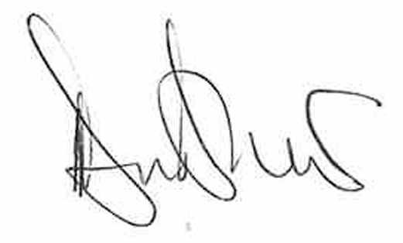
Deanna Bradshaw
Aiker Legal Support

