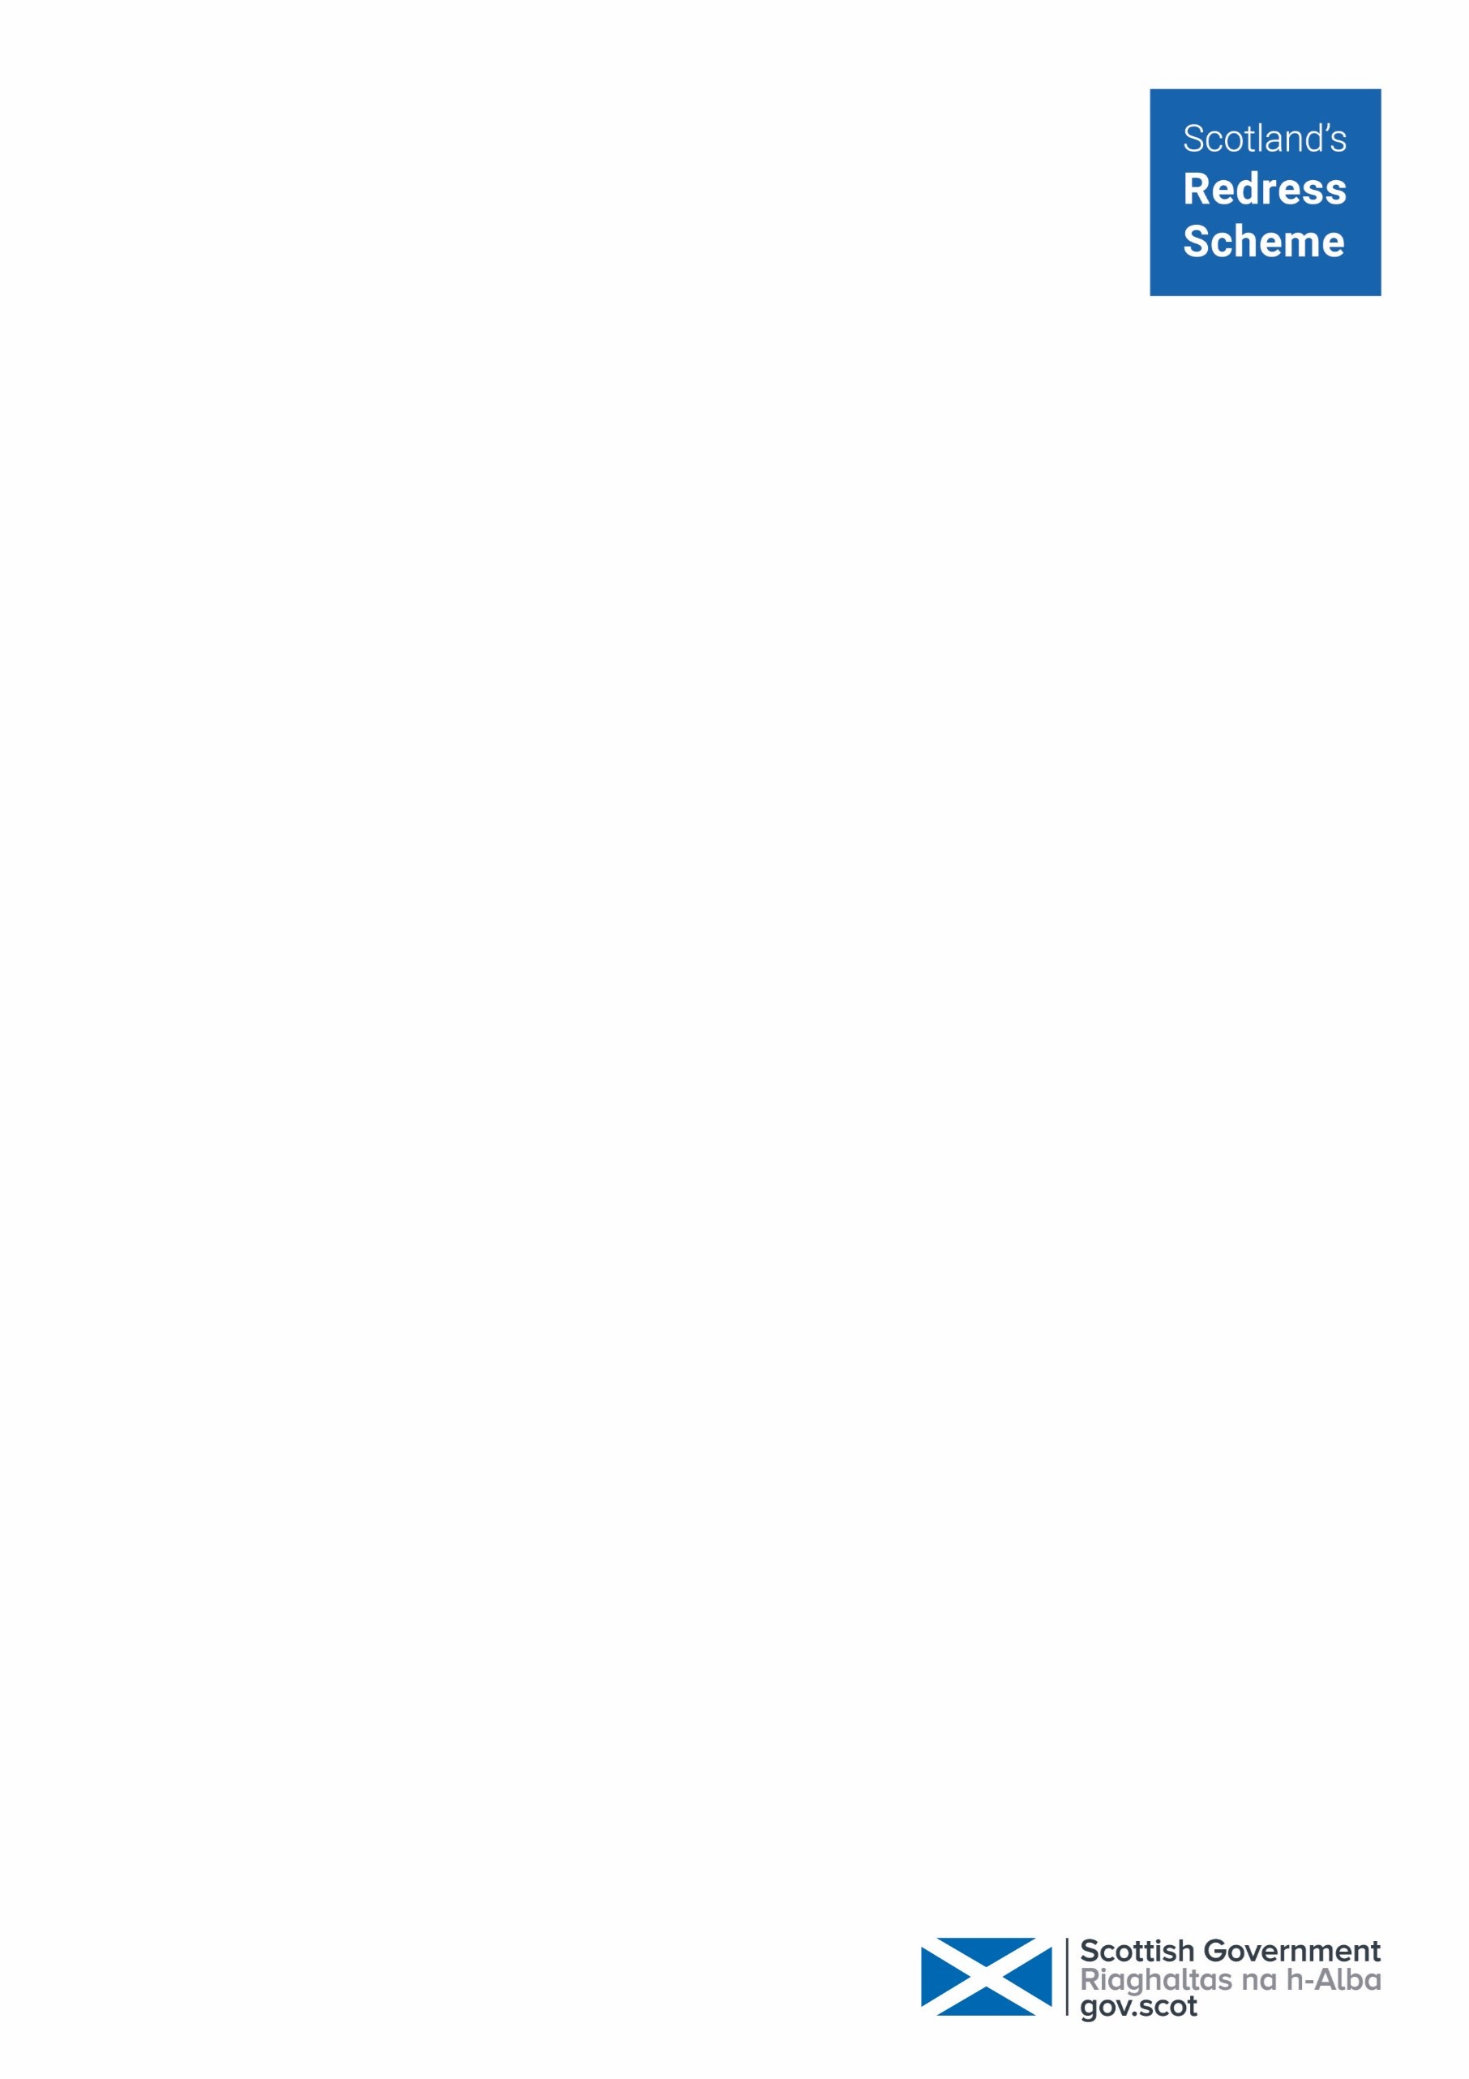

Joanna McKenna
116 Castlebay Street
Glasgow
G22 7LR

29 December 2025

Dear Joanna

I am writing to provide an update in respect of your application to Scotland’s Redress Scheme. We can confirm we received your application on 16 December 2025. Your application reference number is: APP438085.
Your application will be assigned to a designated case worker who will be responsible for working on your application and will be a point of contact throughout the process.
Please note that due to the high volumes of redress applications received, the time taken to have applications assigned to a case worker is taking longer than we would like. Whilst we cannot provide a timescale for how long it may take to have your application assigned to a case worker, it may be helpful to be aware that we are currently assigning applications that were received in February 2025.

We would like to reassure you that we are working hard to ensure your application will be assigned at the earliest opportunity. You can contact the team in the meantime if you wish to discuss your application. They are here to help and answer any questions you may have.
We have reviewed the documents provided to date and provide a summary of the further information required below.
In summary:
- Part 1 Nominated Beneficiary Date of Birth
- Part 3 Statement of Abuse
- Certified ID – information sheet included
- Care records – information sheet included
- Supporting documentation

Support service

We have a support service who can provide practical support with the application, emotional support through the process and support to access records. If you would like to access support from our support service, please contact us on the details below.

Further Information
We are enclosing a copy of a flow chart providing information about the application process.
We provide some further information about the documentation required to progress your application below:

Part 1 Application

In Part 1 of the application form there is some important information missing.

Nominated Beneficiary

Please confirm the full Date of Birth for your nominated beneficiary to allow these details to be recorded.
Part 3 Application
You have ticked on Part 1 that you wish to apply for a individually assessed payment. This means that you need to complete Part 3.
This can be the most difficult part of the application to complete as it requires you to provide a statement of abuse. Please contact us if you would like some support to write your statement. Our Redress Support Service can offer practical support such as transcription and also emotional support.
Certified ID

This information is needed to confirm who you are.
You must do this by providing a certified copy of your identification documents.

I have attached an information sheet regarding the types of identification required by the scheme and how to get them certified.

Care Records

For individually assessed payment applications, you need to provide one document to show you were in the care of each relevant care setting you mention in your application.

Please see page 22 of the “Help to Apply” guidance.

I enclose information sheet regarding the different ways to access care records.

Supporting Documents

For individually assessed payment applications, you need to provide at least one document that supports your statement of abuse.

You can read more about documents you can use on page 33 of the “Help to Apply” guidance.

Further help and support

If you have any questions about the contents of this letter, require additional copies of application forms, or require any further support concerning your application, please don’t hesitate to get in contact with us.

Telephone

0808 175 0808 (freephone)

Lines are open Monday to Thursday from 10am to 4pm, excluding Scottish public holidays. There is an answering machine at other times, and if you leave a message we will get back to you as soon as we can.

Email : apply@redress-scheme.scot

Post : Redress, PO Box 24209, EDINBURGH, EH7 9GT

You can also contact the Redress Emotional Support Helpline directly on 0800 211 8403 where you can leave a message and someone will get back to you as soon as possible.

Kind regards

Scotland’s Redress Scheme

