Mr Darren Spence
30 Dalilea Place
Glasgow
G34 0EL

9th March 2026

Dear Darren,
Ref: Authorisation to Obtain a Scottish Birth Certificate – Redress Application
Further to my telephone call today regarding your application for Redress from the Scottish Government, I have enclosed a copy of the authorisation form we discussed that requires your signature please.
I have also enclosed a pre-paid envelope for you to return the signed form back to our office. I’d be very grateful if you could please ensure this is done as soon as possible to avoid any delays in us obtaining the certificate.
If you have any queries at this stage, please don’t hesitate to contact us. We’re here to support you at every step of the process.
Yours sincerely,
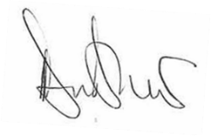
Deanna Bradshaw
Aiker Legal Support
E: support@aikerlegal.org
T: 0203 004 6549

