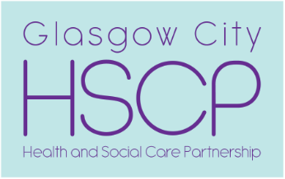  , | Chief Officer  Pat Togher  BA Social Work | Glasgow City Health and Social Care Partnership  Commonwealth House  32 Albion Street  Glasgow  G1 1LH  www.glasgow.gov.uk  www.nhsggc.org.uk

Our Ref: 20260416-DP8566530-MMAL
Your Ref: 100202
Date: 16 April 2026

MMA Legal
evidence@mmalegal.co.uk

Dear Sirs

Subject Access Request
Your Client: Toni Marie Cullen

I write to acknowledge your request for access to records which was sent to the Complaints, FOIs and Investigations Team (CFIT) by email on 15 April 2026.

Unfortunately, the mandate attached is not considered by us as valid. In order to progress your request, please resubmit a mandate ‘wet ink’ signed by your client.

Please be advised your request is on hold until we receive a valid mandate. If we do not receive this by 16 May 2026, your request will be closed.

We are currently managing a significant backlog of requests – over 865 as of today’s date. This is the result of factors including an increased number of requests arising from Scotland’s Redress Scheme.

This backlog means that it is highly unlikely that we will be able to respond to your request within the statutory deadline of one calendar month. We may still be able to meet this deadline where requests are for relatively small amounts of personal data.

In terms of efforts to address this issue, our team are working to address the backlog, additional staff have been recruited to help supplement this and colleagues from across the organisation are also providing support to help lessen delays.

Complaints:
We aim to directly resolve all complaints about how we handle personal information. If your complaint is about how we have handled your request for personal information, you can contact the Council’s Data Protection Officer by email at dataprotection@glasgow.gov.uk

However, you also have the right to lodge a complaint about data protection matters with the Information Commissioner's Office, who can be contacted by post at: Information Commissioner's Office, Wycliffe House, Water Lane, Wilmslow, Cheshire, SK9 5AF. By phone on 0303 123 1113 (local rate). Visit their website for more information at- https://ico.org.uk/make-a-complaint/

Yours faithfully

Lorna Fitzpatrick

Lorna Fitzpatrick
Resource Worker
Complaints, FOI and Investigations Team
Glasgow City Health and Social Care Partnership

If phoning or visiting, please ask for Lorna Fitzpatrick
Telephone 07741291366
Email DataProtection@sw.glasgow.gov.uk

