WITNESS STATEMENT OF FRANCES MCGOWAN
—-----------------------------------------------------------------------------------------------------------
Application to The Scottish Redress Scheme
Applicant: Ms Frances McGowan
Date of Birth: 19 January 1969
Application Reference: APP976972

Support Person Present: No
—-------------------------------------------------------------------------------------------------------------

Background
- My name is Frances McGowan. My name as a child was Frances McGowan.
- My address is 359 Peat Road, Glasgow, G53 6SE.
- I make this statement in support of my application to The Scottish Redress Scheme.
- The contents of this statement are true to the best of my knowledge and belief. Where I cannot remember exact dates or details, I have made this clear. I confirm I have provided as much detail as I am able to recall.
- I understand that this statement will be considered as part of my application, together with my application forms and any supporting documents or records provided.
- Where necessary, I have exhibited extracts of the supporting documents obtained to this statement to support my application.

- I am happy for this statement to be submitted to the Scottish Redress Inquiry.
- I do not need any support to conduct this statement today and I do not need anybody with me to complete the statement.
- I understand the purpose of this statement and that it is in support of my Scottish Redress Application.
- I do not have nor have I ever had any criminal convictions.
- I was placed into care whilst under the age of 16. The care setting was based in Scotland.
- At the time, I was living in a care setting as part of the care arrangements.
- I was approximately 5 or 6 years old when I went into care.
- I am unsure who placed me into care or why I was placed into care.
- The placement I was in was a children’s home.

Life Before Care
- Growing up, I lived in a single end house. I lived there with my Mum, Dad, 2 brothers and 2 sisters. We never really had much; Mum and Dad didn’t work either.
- Having 2 brothers and 2 sisters was great. I was the middle child, the third child.
- We had just a normal family life. It wasn’t a brilliant time and we didn’t have much, but that was just life then you had to crack on.
- I do remember my Mum had bad agoraphobia and couldn’t go out, so me and my siblings were made to play inside and never really went out.
- I don’t know if my Mum got like this because we moved away from everyone and then she sort of had, like a breakdown because we moved to a new area. I’m not sure.
- I do know that we had to make do with what we had and I was around 6 years of age when things started to change.

Entry Into Care
- I was taken from my parents when I was around 6.
- I was never told that I was going into care and I still do not know why I was taken into care after all this time.
- I do remember my Mum saying something along the lines of her going into hospital and my dad was unable to look after us but it’s not a very strong memory.
- I think my Mum blamed Social Services for me and my siblings being in care.
- Me and my siblings were all taken to a sort of respite house. It was a big, massive thing.
- We were only there for 1 night and then taken to another home, Nazareth House.
- After this, my younger brother and I were kept together, and my two eldest siblings and my youngest siblings were separated from us. We were taken to Nazareth.
- The 2 oldest and the youngest went to a different location, somewhere in Aberdeen, which is under a different Council.
- I don’t know if this was a choice of social workers or if they were told to do it by Court or something.
- At the time, I was so scared. I felt absolutely petrified.
- I remember gripping on to my eldest sister so that I wouldn’t be taken away with strangers.
- Me and my siblings were all petrified. We had all just been taken by strangers, not told what was happening and then left in a strange house.
- I remember my elder brother kicking off. He started kicking and screaming because none of us knew what was happening and he was trying to help and protect us.
- We all just cried but had no other choice but to stop and eventually it all calmed down.
- It was good that one of my siblings was there to calm me down, but this didn’t leave me. It left me with severe separation anxiety, and I seriously wouldn’t wish that feeling on anybody.

Detailed Account of Each Placement
Nazareth House
- I entered care with Nazareth House. “EXHIBIT 1” will show that I was admitted on 11 December 1975 until 13 August 1976. Further to this, in “EXHIBIT 2” you will see Nazareth House’ register with my details confirming my time spent there.
- I was placed in this care setting by Glasgow Social Work Department.
- From what I can remember, there were like, maybe 6 people in a big room, but when I was there, there was me and another girl in my bedroom.
- There were all different rooms with different kids, there was a room where the nuns stayed and there were multiple levels of the home it was huge.
- Day to day activity there wasn’t bad. It was a case of getting up, dressed and going to school.
- Everyone had dinner after school and then everyone would go and play in the back garden which was massive.
- I remember this all being summertime, well warm. All that side of the home was ok.
- We had hair washing and bathing days.
- There was like a bench and a stool, and staff would wash your hair.
- Everyone would all sit together and get it done at the same time.
- I remember staff pulling my head back and forward and moving it around, very roughly, very roughly.
- I didn’t look forward to it because I knew how rough it would be and how it could hurt.
- I was a bedwetter as a child. I wet the bed prior to going into care and even when I left care.
- As a punishment for this, staff would take me out of bed and place me into a freezing cold bath.
- They would shout at me, belittle me and call me names like “dirty”, “bad” & “unwanted”.
- I’d just sit there in the cold bath and cry. I was made to feel bad for wetting a bed in my sleep.
- There was never any “don’t worry about it” or “it’ll be ok” they were strict and mean about it.
- I always get this memory of them given me this Alpen breakfast and I couldn't eat it and one member of staff made me eat it when i got home. I don’t know why this memory has stuck in my head but I remember them telling me to eat it after school.
- The nuns were scary, but there was one, sister Ann and for some reason I liked her. I think she was a fair nun, strict, but fair. She wasn’t like the others.
- I don’t remember all the staff that much, but they weren’t nice. They were rough and would pull your hair and head when washing.
- I remember being all blistered once from the sun and they never had any suncream.
- To be honest, they looked after us the way they looked after us. But a lot of it I’ve blocked out because they were bad memories.
- We went to school and it was like a really old-fashioned school.
- I was scared to go the toilet because it was down scary corridors and stuff and because I was scared to ask to go to the toilet, I would wet myself and get in trouble for it. I was just a young little girl I didn’t understand it.
- In Nazareth house, I can’t remember if there were rules. You were to behave; you couldn’t run wild or anything you know.
- You could go out and have fun but, in the house, you had to behave.
- I also remember staff listening in to calls with family.
- I used to speak too my Mum on the phone and then you would hear them picking up another phone to listen in, you know on the old-fashioned ones, and it would make a noise, and my Mum would say “they are listening”.
- I don’t remember every punishment, but I do remember the wet-bed – cold-bath punishment. You’d be dragged out of the bed and placed into a freezing cold bath.
- Now I am older and wiser, I understand that the cold baths and hair pulling etc are not acceptable and were not acceptable and I would class them both as a form of abuse.
- Other than the above, I don’t remember any further physical abuse.
- I was allowed visits and communication with family and friends.
- I was never made to watch or take part in any form of abuse.
- The food and drink were fine. I never felt malnourished.
- I had everything I needed in respect of clothes and shoes etc.
- I can’t remember the toiletries aspect, but I am pretty sure I was clean. We did bath and washed regularly.
- Nazareth was a big place; well, it looked big at the time. It was clean and cared for from what I remember.
- I was never locked away in confined areas.
- I can’t remember about appointments so I can’t comment on that.
- The staff were supportive of my school and education.
- I do remember one incident where my shoes were too small and I was made to go to school for a few days still, but other than that it was fine.
- A couple of the girls in care would give cuddles and show affection but I can’t remember the staff or nuns doing anything or a birthday card or Xmas gift.
- I didn’t feel safe in Nazareth. I knew I’d been taken from family and left with strangers. You can’t feel safe when that happens.
- I never ran away from the home. I never even tried. I was too scared.
- Nazareth House was the only care setting I was placed in.

Frequency, Duration & Patterns
- The above abuse happened every time. Every time I would wet the bed or every time it was hair wash day. I hated hair wash day, and I hated waking up wet knowing what was coming.
- This went on for around 8 months.
- I don’t remember this escalating over time.
- We would wash our hair downstairs as there were multiple sinks and we would all sit around them.
- The cold baths would be in the bathroom which was on the landing next to the bedrooms.
- This happened once a week on hair wash day and every time I would wet the bed.
- When the abuse would happen, you would be told to strip down and get into the bath while is was freezing with some angry words or whatever and they would come and get you and get you ready for school.
- I was so fearful and anxious. I was scared of wetting the bed and I’d lay there hoping I wouldn’t wet the bet, but I really couldn’t help it. Its left me with a lot of fear and anxiety.

People Involved, Witnesses & Siblings
- I don’t know if anything similar happened to other people.
- I do think that we were all treated the same though.
- I didn’t witness this happening to anybody else because it was so early in the morning.
- The abuse was conducted by multiple members of staff. I don’t know if all of them did it, but multiple members did.
- I remember it was carers and Nuns, but I don’t remember anyone specific.
- I was so scared as they had authority over me.
- No one ever spoke or complained about it. It felt like a bit of a daydream. I think the older kids would remember more.
- I was never abused, bullied, threatened, assaulted, sexually abused, exploited, or intimidated by any of the other children.
- We all stayed in the dorms. In a way it was a wee bit luxury having your own bed etc.
- As I stated earlier, me and my brother were kept together, and my other siblings were moved away. Wash day was the same for every child in the home. I don’t know if there was any bedwetting from my sibling in any event.

Reporting & Responses
- I told my Mum on the phone about the abuse that was happening.
- You could hear people listening into the call so we would stop speaking to it.
- My Mum did believe me, but nothing could be done.
- I don’t remember anybody asking if I was ok, if anything had happened.
- I don’t know if complaints were discouraged but I wouldn’t know because I never spoke about my abuse and I don’t think anybody else did either.
- I couldn’t tell the police or report it to anybody, when you’re a child you don’t really think of these things, you know.

Impact On Life Past/Present/Future
- The abuse I received has and remains to have an impact on my life.
- I was crying and scared all the time as a child. I was very fearful all the time. This has had an impact on my life more than you may think.
- I have suffered with and continue to suffer with general anxiety, separation anxiety, OCD and some depression.
- This has led to me being medicated with multiple mental health drugs such as Propranolol, Zopiclone, Diazepam and Sertraline.
- I have evidence both my GP records and medication sheets at “EXHIBIT 3”.
- Ive always had a fear growing up that it would happen again, that I could be taken away or something. Ive always been insecure about it.
- It effects my relationships with people and has always affected my relationships with people. The people I went to school with, people in my life now, you know, like family and partners and stuff.
- I have struggled with work and education and continue to struggle every day.
- I was more of a kind of a day dreamer to take my mind away from things growing up, but I still do that now, just to escape or forget about it.
- I didn’t do well in school or anything because this just left me such a scared and anxious person. This caused me a disadvantage to others growing up.
- My life could have been different if I never had to grow up scared and anxious.
- I’ve never drank or smoked to deal with this, but I have had medication from my GP.
- This has affected my trust, safety, relationships, education and behaviour.
- I have experienced, fear, shame, guilt, anger, flashbacks, nightmares, panic, depression, anxiety, low moods, tearfulness, intrusive thoughts and emotional distress.
- I get flashbacks and nightmares of the bath. I can remember them things clearly. I do get some good memories like but mostly bad.
- This has affected my relationships I’m so insecure. I have 4 beautiful girls. I knew not to do this with my children because it’s wrong and I know that life was different back then.
- I don’t really get triggered, but when you watch a documentary of a child being taken away or anything like that, you really feel it for them you know, because you know how it felt.
- There are kids in the world that need to be taken into social care, I get that, but when you’re a child you don’t understand and it’s such a big scary thing happening in your life and nobody cared for me.
- I really do try my best not to dwell on things.
- I am a busy Mum, and a busy Nana and I feel so blessed that I do have these things to occupy me and keep me busy because all of this stuff, going over it again and again isn’t good on your mental health.
- The anxiety, OCD and depression that I’ve dealt with has stemmed from my time in care.
- I don’t know what my life would have been like if I hadn’t been put in care. I believe my mental health is in the condition it is due to my time in care.
Long-Term Impact on My Adult Life

- The physical, emotional abuse and neglect I experienced in care has had a lasting impact on my life.

- The impact has included:

Mental health: Anxiety, Depression, OCD, Emotional Distress and Intrusive thoughts.
Relationships: Difficulty trusting and relationship breakdown.
Education and employment: Missed opportunities and difficulty holding employment.
Identity and self-worth: Shame, guilt, feeling different, self-consciousness.

I have received the following treatment/medication: Propranolol, Zopiclone, Diazepam and Sertraline.

Supporting Evidence & Records

- I understand that records and documents may be considered alongside this statement. I have exhibited, as necessary, documents to this statement.
- I have also provided a bundle of evidence in addition to this statement, these are all of the relevant documents my legal representatives have been able to obtain on my behalf, from relevant institutions, local authorities, and medical practices.
- Some records may be incomplete, missing, or unavailable due to the passage of time. Where records are missing, I ask that my own account still be considered carefully. I have done all in my power, with the assistance of my legal representative, to obtain and provide as much evidence as possible.
- I have had my legal representative to redact any information that’s not relevant to my Scottish Redress Application.

Difficulties with Memory and Gaps in Evidence
- The events described happened many years ago. Some dates, names and details are difficult for me to remember.
- My memory has also been affected by the trauma of what happened to me.
- Where I have used approximate dates or descriptions, I have done so honestly and to the best of my recollection.
- I have not intentionally exaggerated or included anything that I do not believe to be true.
Why Am I Applying to the Scottish Redress Scheme
- I am applying because I experienced abuse and/or neglect while I was a child in care in Scotland.
- I want my experiences to be acknowledged.
- The abuse and neglect I suffered has had a significant and lasting impact on my life.
- I am seeking redress in recognition of what happened to me and the harm that I have lived with since.

Final Statement
- Overall, I wish this never happened. But it did and I don’t know, I just would have liked to understand why it happened but I’m a little bit scared to as you know the saying, what you don’t know can’t hurt you.
- Ive made peace with all of this as its done and dusted. But this shouldn’t have happened to me.
- I’m not here to hurt anybody or get anyone in trouble, I’ve been through enough, So I don’t want all stuff like that, you know, any more trouble or bother.
- I have never made a previous civil claim, criminal injury claim, Redress application, advance payment application, complaint, police report, inquiry statement, or claim to another scheme about this abuse.
- I have never received any payment, apology, response or settlement in respect of my Scottish Redress Claim or abuse.
- I have never signed any waiver, settlement agreement, discharge, or acceptance form in respect of my Scottish Redress Claim or abuse.
- Going through this again has been triggering and something that I want to disappear when this is over. I’m done with it all now.
- I have tried to provide a full and honest account of my experiences, to the best of my knowledge and belief.

- I ask that Redress Scotland considers this statement, my application forms, and the supporting evidence I have submitted when determining my application.

Statement of Truth
I believe that the facts stated in this witness statement are true.

Name: Ms Frances McGowan

Signed:

Dated:

EXHIBIT 1
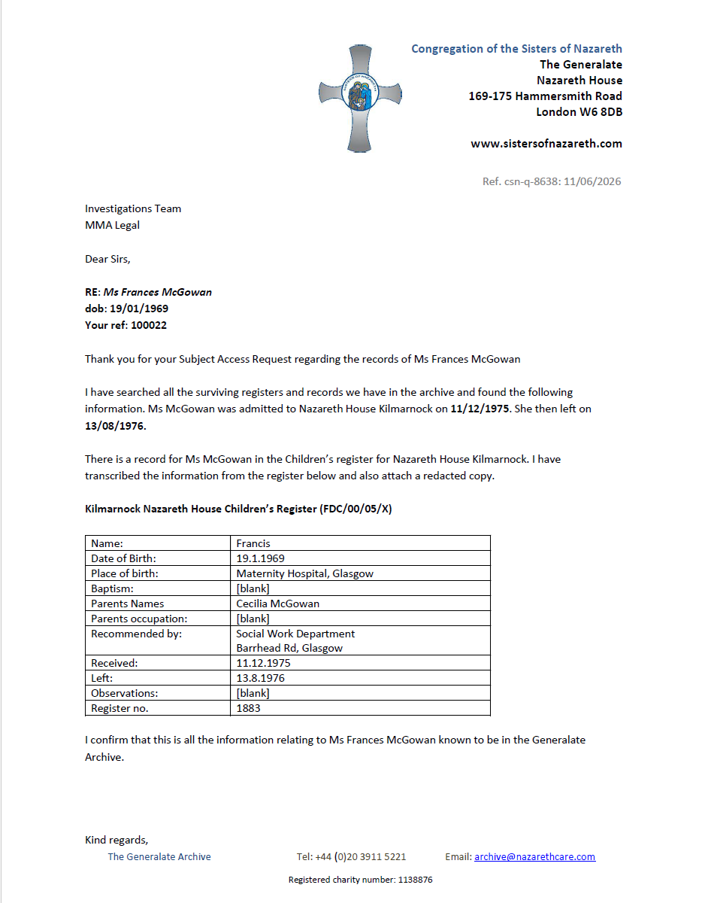

EXHIBIT 2

EXHIBIT 3
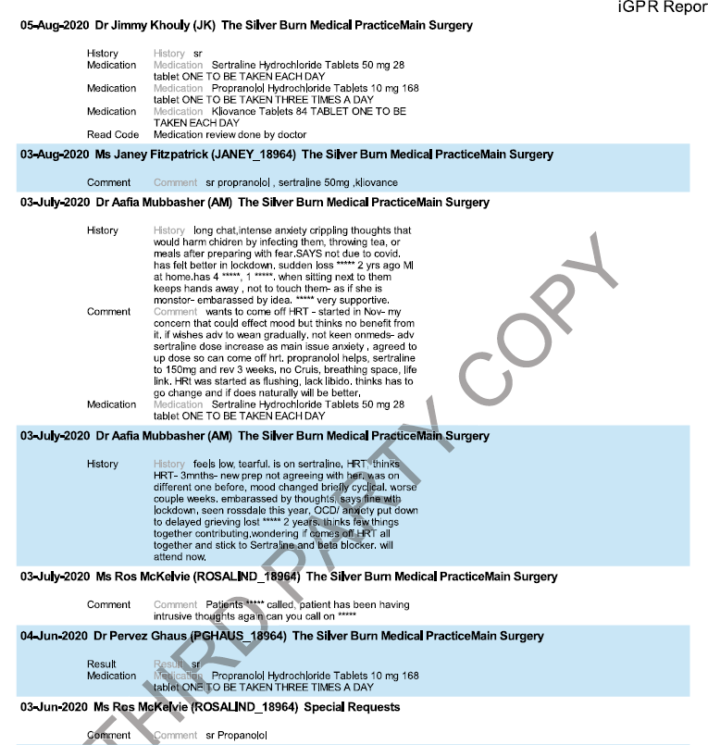
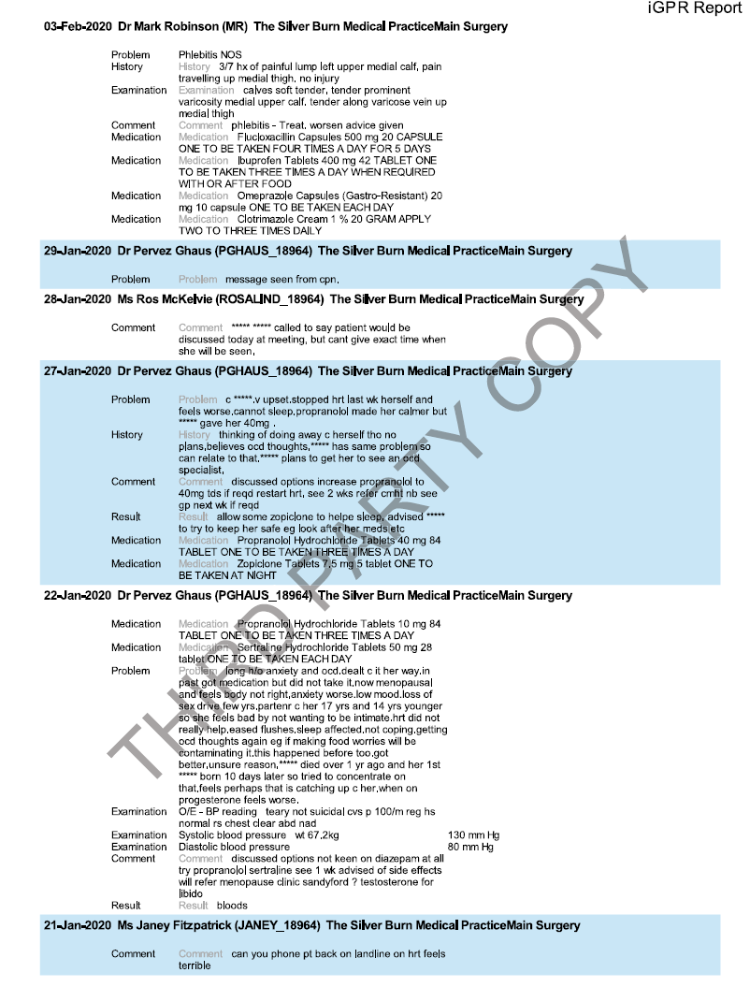
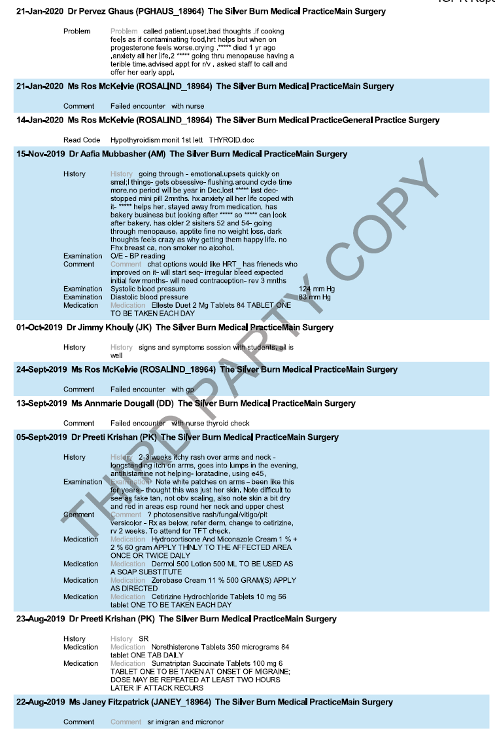
EXHIBIT 4

