First Time Login for Guests
When you click on the link in the invatation email you will be presented with a Microsoft Sign in screen, as shown below. It’s important that you enter the email address the link was sent to:
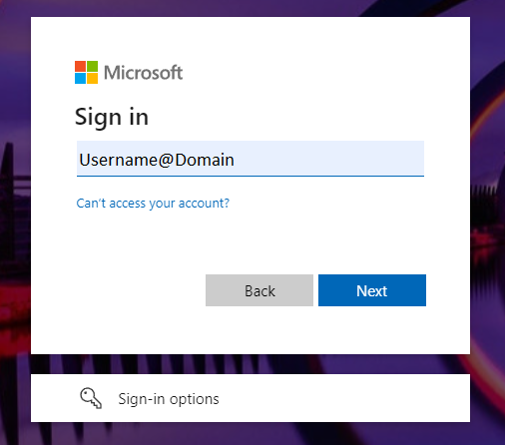

When you click ‘Next’ it will send a verification code to your email address. The code should then be entered in the presented field, then click ‘Sign in’:
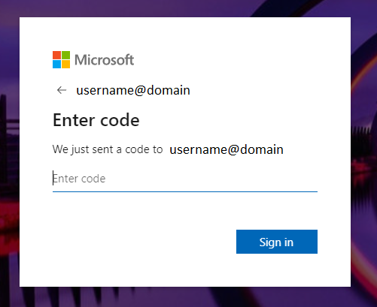
Once your code is accepted, you will be prompted to ‘Accept’ the permission request as shown below:

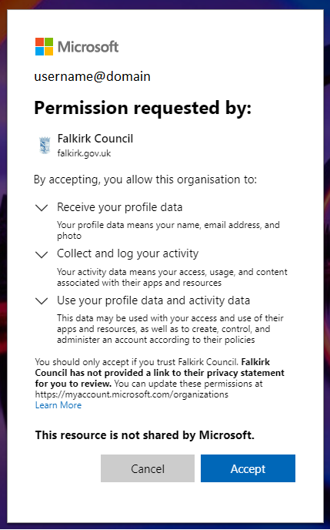

The screen below will flash up briefly…
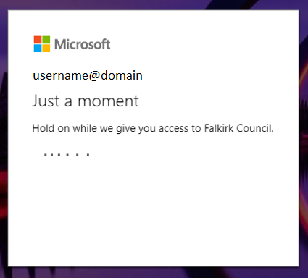

…then you are taken to the screen below. Select Next:
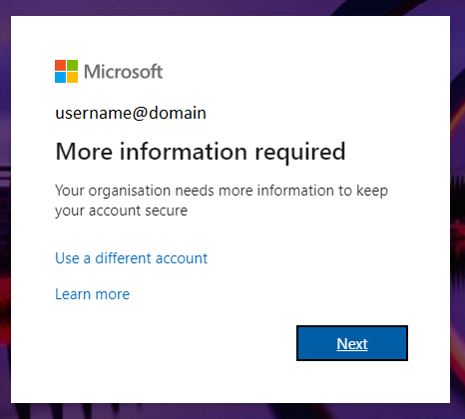

Complete the ‘Additional security verification’ screen, selecting United Kingdom from the drop-down list and entering your mobile number. If you want to authenticate by text message, make sure you select this method. Click ‘Next’ to submit your details.

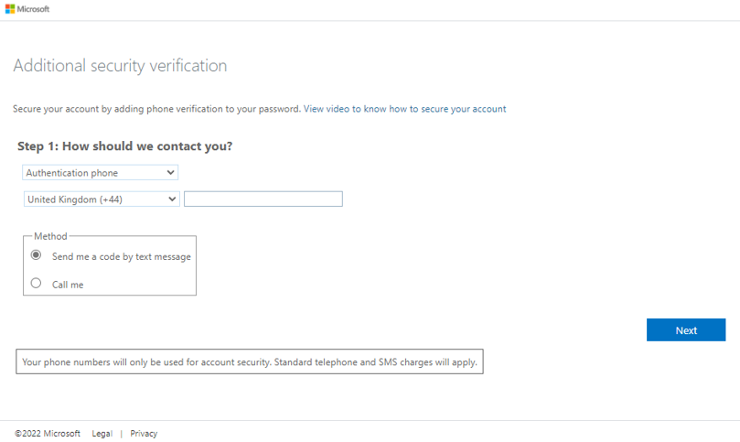

You will then be taken to a screen to enter the verification code sent to your phone:

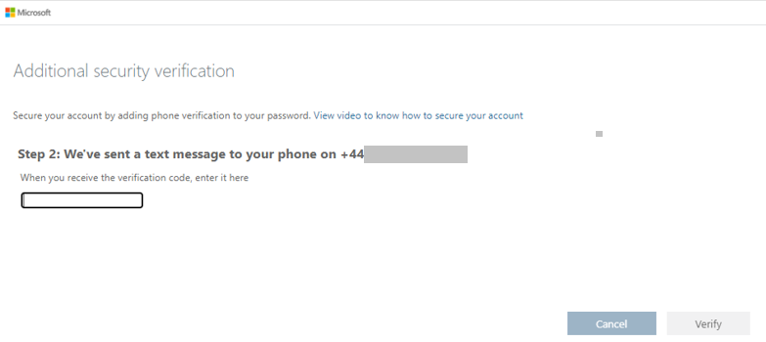

Once you have entered the code and selected ‘Verify’, you should get a message saying ‘verification successful’ as shown on the next page.

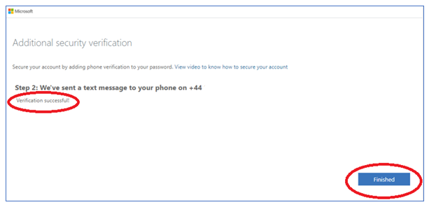

Clicking on the ‘Finished’ button will take you into the Team/SharePoint Site

