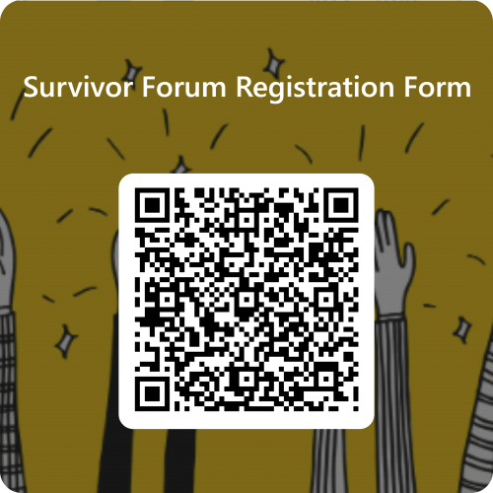
Survivor Forum Registration Form
Scan QR code to complete

Please complete this form if you wish to join the Survivor Forum and give your consent for the Scottish Government Survivor Relations Team to contact you regarding Survivor Forum activities and updates.
Any information you provide will be stored securely and confidentially, in accordance with the Scotland's Redress Scheme Privacy Notice.
Full name

Preferred method of contact (please circle)
Email Post
If your preferred method of contact is email, please enter your email address below
If your preferred method of contact is post, please enter your postal address below
Member details
It is helpful for us to understand more about who is joining the Survivor Forum so that we can tailor our communications appropriately. Please circle the term that best describes you, if you are happy to do so
Survivor | Survivor’s representative eg solicitor | Next of kin
Next of kin | Other | Please specify
Please provide any additional information here that you think would be helpful for the Scottish Government Survivor Relations Team to be aware of, in relation to your participation in the Survivor Forum
You can leave the Survivor Forum at any time by emailing Survivor.Forum@gov.scot
Or write to us at FREEPOST Survivors Forum
Please post back to us in enclosed envelope
Please do not write anything on the envelope

