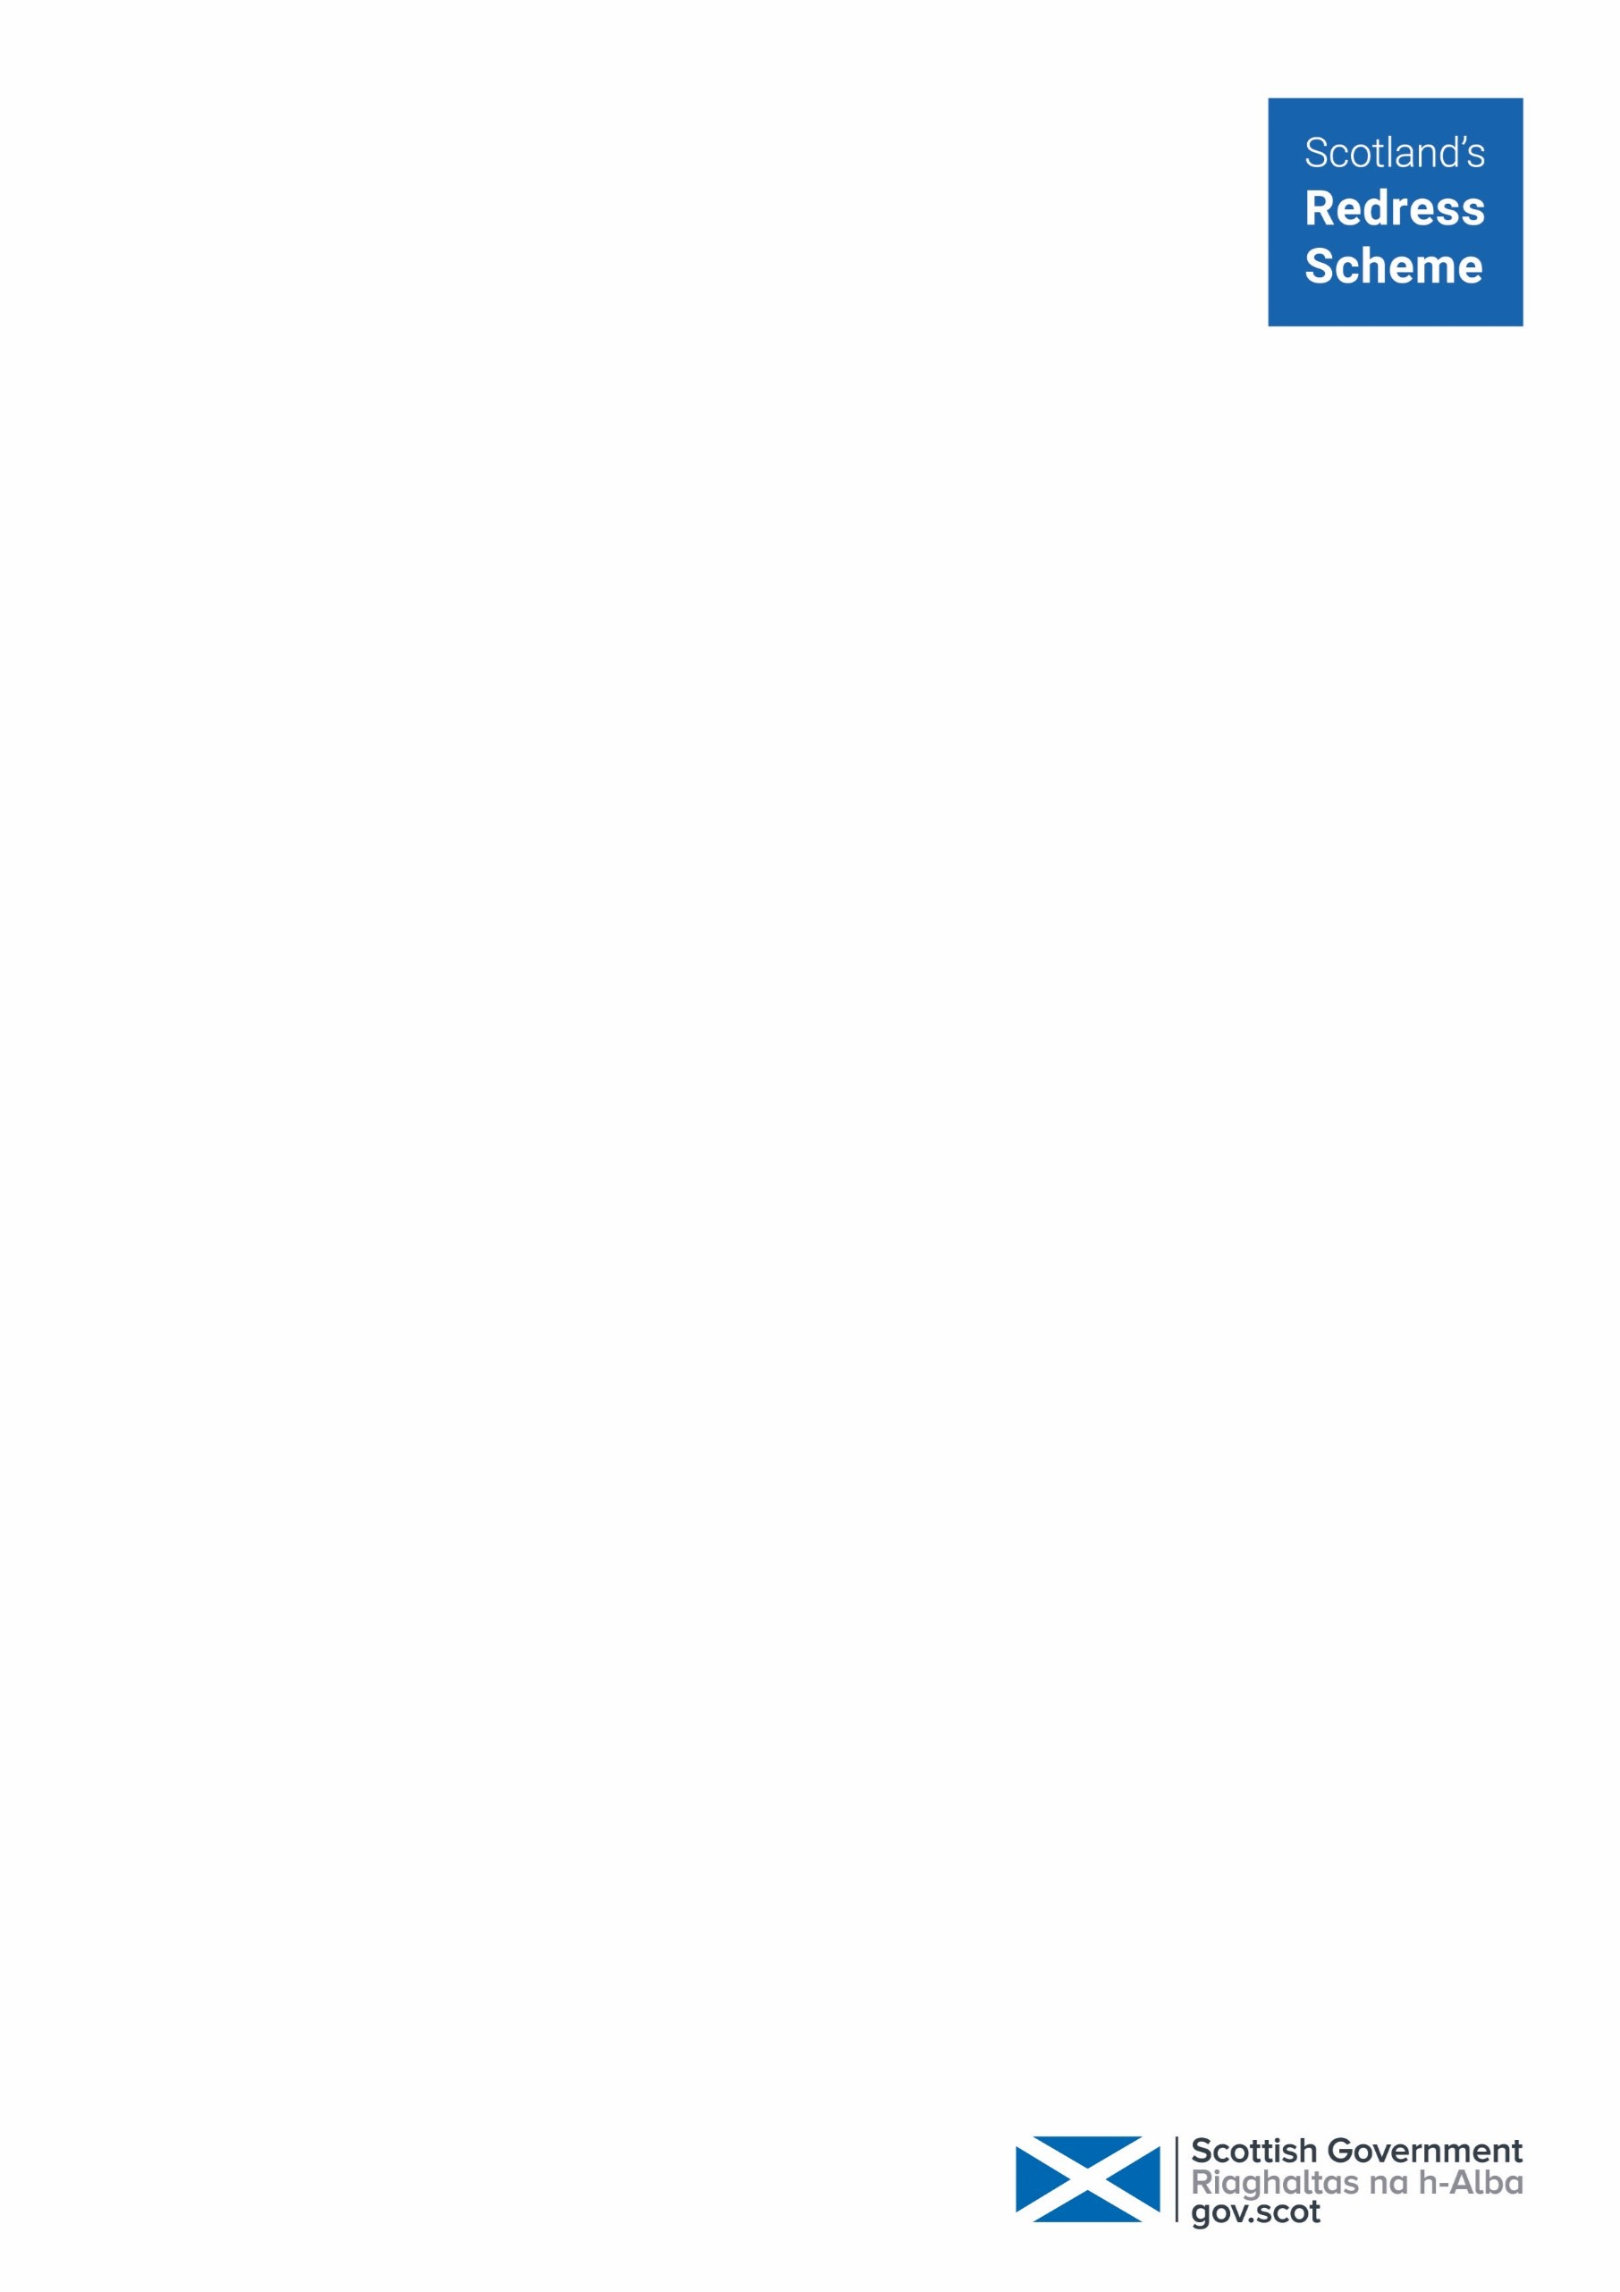
Gavin McClymont
10 Everard Quadrant
Glasgow
Glasgow City
G21 1XP

3rd July 2026

Dear Gavin,

My name is Claudia and I will be responsible for working on your application and communicating with you.

Following on from the first assessment letter we sent you on 17/03/2026, I have further reviewed your application and thank you for the documents received to date. I outline below the further information required to progress your application. Please let me know how often you would like me to contact you to discuss progress.

Information required
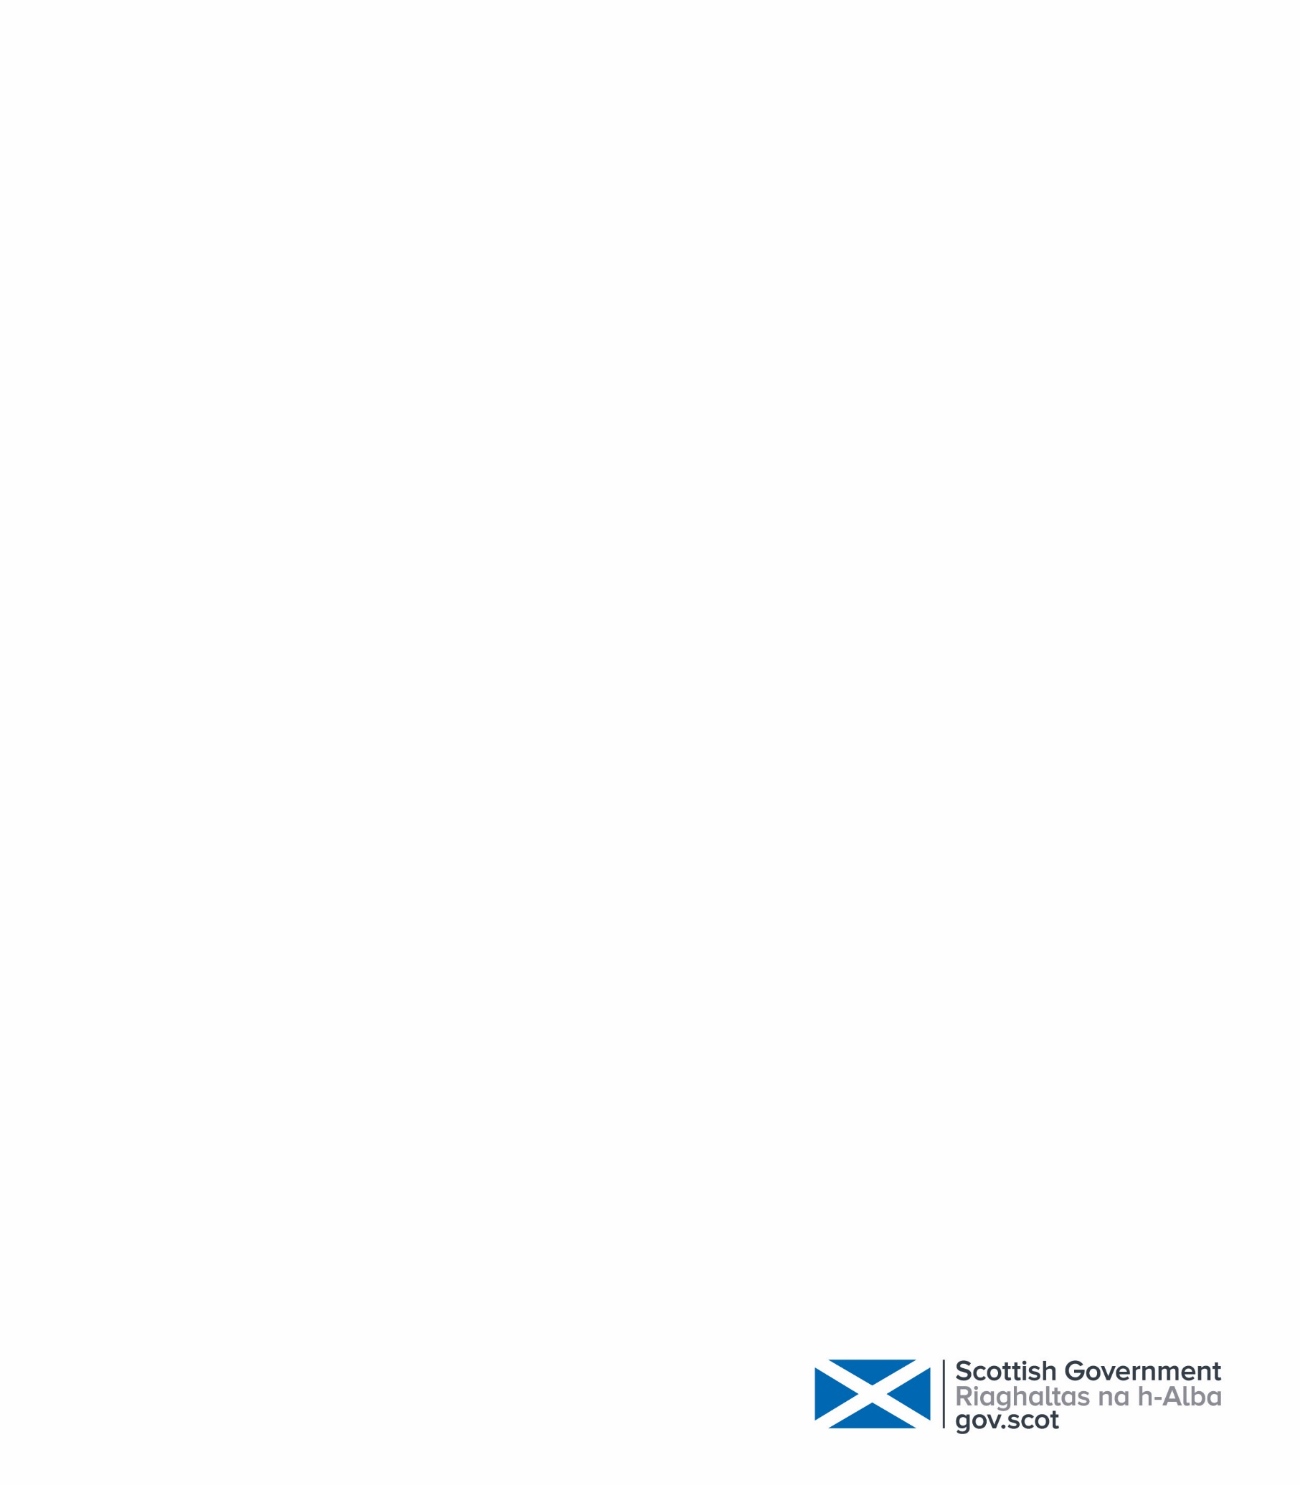
Part 3 Application

You have completed Part 3 of the application, thank you, however you have not dated the declaration page.

Statement of Abuse

In order to process your application, we require a statement of abuse for each care setting. You should try to include as much information as possible about what happened to you.

Date of Birth and contact details for your Nominated Beneficiary

You have named Alice McClymont as your nominated beneficiary. In order to put this on your record, we require Alice’s date of birth and either an address, phone number or email address for her.

Terminal Illness

You have provided some information under section 4 of the application regarding terminal illness. Please could you contact us immediately to confirm your health status in order that we can prioritise your application appropriately.

If you have a terminal illness, Scotland’s Redress Scheme will prioritise your application. You can choose to provide evidence of your illness using a copy of your DS1500 or BASRiS document. Please do not send the original.

If you do not have a DS1500 or BASRiS form, you can provide:
• a medical reference number
• the details of a health practitioner who can confirm your diagnosis
Please see page 15 of the “Help to Apply” guidance.

Serious Convictions

We need you to confirm if you have any relevant convictions.
If you have a conviction for a serious criminal offence, either:
• A conviction for rape or murder
• Received a sentence of imprisonment of 5 years or more for a relevant violent or sexual offence
You will need to provide a full criminal record. You can access your police records by making a subject access request to obtain this information from Police Scotland. There is guidance about how to do this on the Police Scotland website (scotland.police.uk)

Bank Statement

You have not provided your bank details. In order to ensure any payment is only received by applicants we will require a bank statement to confirm your account. We do not need to see any transactions, simply your name, address, sort code and account number. If you have any questions regarding this please do not hesitate to contact me.

Certified ID

This information is needed to confirm who you are.
You must do this by providing a certified copy of your identification documents.

I have enclosed/attached an information sheet regarding the types of identification required by the scheme and how to get them certified.

Care Records

For individually assessed payment applications, you need to provide one document to show you were in the care of each relevant care setting you mention in your application.
Please see page 22 of the “Help to Apply” guidance.

Supporting Documents

For individually assessed payment applications, you need to provide at least one document that supports your statement of abuse.
You can read more about documents you can use on page 33 of the “Help to Apply” guidance.

Support Service

We have a support service who can provide practical support with the application, emotional support through the process and support to access records.
If you would like to access support from our support service, please let me know.

Summary

In summary: in order to progress your application we will require:

• Part 3 (date only)
• Statement of abuse
• Date of Birth and contact details for Alice McClymont
• Confirmation of any Terminal Illness
• Confirmation of any relevant convictions
• Bank Statement
• Certified ID
• Care records
• Supporting documentation

If you have any questions about the contents of this letter, require additional copies of application forms, or require any further support concerning your application, please don’t hesitate to contact me.

Telephone – 0808 175 0808 (Freephone) + 44 131 297 6500 (international)
Lines are open Monday to Thursday, from 10am to 4pm (except Scottish public holidays)
There is an answering machine at other times, and if you leave a message we will get back to you as soon as we can.

Email – apply@redress-scheme.scot

Post – Redress, PO Box 24209, EDINBURGH EH7 9GT

You can also contact the Redress Emotional Support Helpline on 0800 211 8403 where you can leave a message and someone will get back to you as soon as possible.

Kind Regards

Claudia
Case worker
Scotland’s Redress Scheme

