SCT Acorn House Referral Form

Please read this pack carefully and complete each section in full.

Name of Applicant | Colin Kerr
Referral Date | 24/09/25

Please send the completed referral form to referrals@sct.org.uk. The application will be assessed and you will be contacted about next steps



Spitalfields Crypt Trust
Acorn House, 116-118 Shoreditch High Street, London, E1 6JN Registered charity No. 1075947
Company No. 3734793
0207 613 5677

Referral Details

Agency referring | Self referral
Name of referral worker
Referral contact details (telephone, email, address, borough)

Source of referral (please tick)
Voluntary agency |  | Statutory agency
Other (please state):
How long have you known the applicant?

About Acorn House
Acorn House is a residential rehabilitation centre for men struggling with homelessness and addiction. It is an abstinence-based service and residents are tested regularly. If a test shows positive for alcohol or any substance, we will endeavour to ensure a resident has alternative accommodation and they will be required to leave. Because of this, we have restrictions on the medication residents can take whilst in Acorn House. We do not accept applicants on a methadone or Subutex script, or any other opiate based medication.
However, if there is a detox plan or a scheduled detox, we would welcome the referral and work with the detox coordinator to ensure a smooth transition into Acorn House. Acorn House is funded by housing benefit, meaning that residents need to be eligible for benefits. Support workers will work with the residents to apply for HB and any other benefits they may be eligible for. There is a weekly service charge that residents are expected to pay.
Residents cannot work whilst participating in the acorn house programme. Residents are expected to participate in the upkeep of the house. The Acorn House programme consists of:

- Group counselling sessions three times a week
- One-to-one counselling sessions once a week
- One-to-one keywork sessions once a week
- Daily morning reflections
- Training and Development classes twice a week
- An in-house AA/NA meeting once a week. There is a further expectation that residents attend at least 4 AA/NA meetings each week.

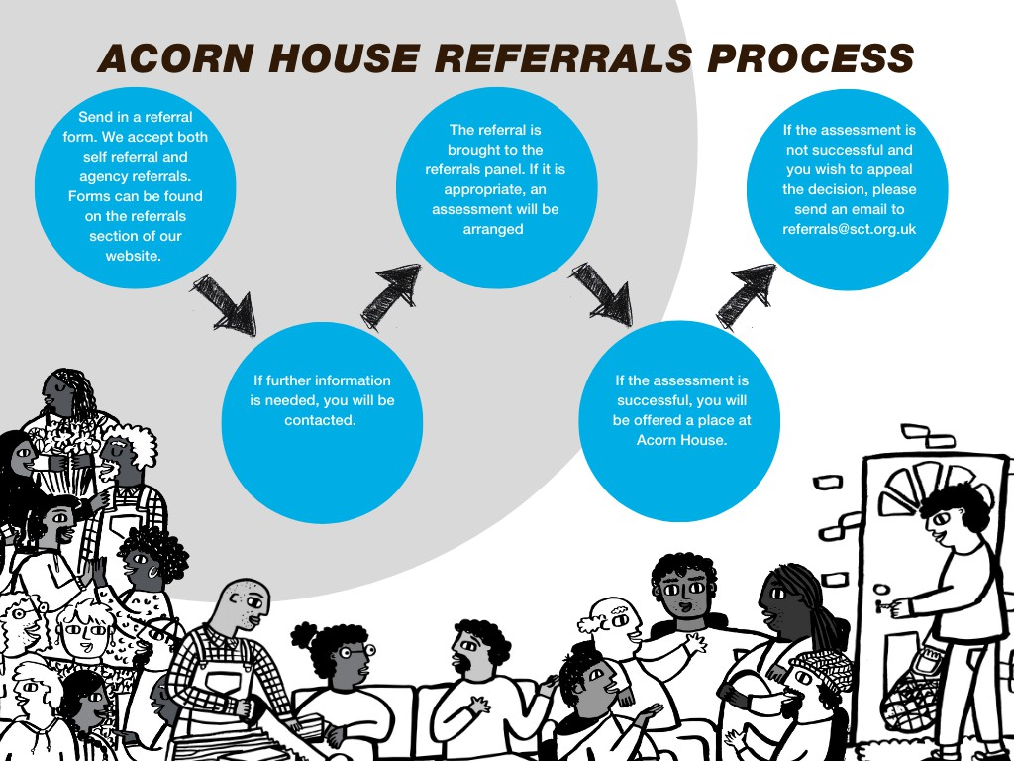

Acorn House Referral Criteria

Is the applicant: | Yes | No
Are you able to participate and engage in the programme at Acorn House? | Y
Are you able to walk up and down stairs unaided? | Y
Are you able to ask for help when you need it? | Y
Are you willing to pay a weekly service charge? | Y
Are you able to share with people from a variety of backgrounds, ages, sexual orientations, races, colours, cultures, and abilities? | Y
Are you eligible for welfare benefits? | Y
Do you currently have a tenancy? |  | N
Are you able to manage your own prescribed medication (with support)? | Y

Personal Details

First name | Colin
Surname | Kerr
Age | 45
Date of birth | 29/11/1979
Place of birth (town and country) | Glasgow. Grew up in Bethnal green
Next of Kin / Emergency Contact Name | Clare Lyons
Next of Kin / Emergency Contact Phone Number | 07814135871
Please confirm you are happy for us to contact your emergency contact  in situations where we feel it is appropriate. | Yes X No

Gender (please tick)
Male | X | Non-binary
Female |  | Other (please state below):
Transgender

Nationality | British
Have you been in the armed forces? |  | Yes |  | No | X

Faith & Religion (please tick)
Christian | X | Muslim
Buddhist |  | Sikh
Hindu |  | None
Jewish |  | Prefer not to say
Other

Ethnic Origin (please tick)

White
English | X | Irish
Welsh |  | Traveller
Scottish |  | Prefer not to say
Northern Irish |  | Any other white background (please state below)
British

Black/African/Caribbean/Black British
African |  | Prefer not to say
Caribbean |  | Any other black/African/Caribbean /Black British backround (please state below)

Mixed/Multiple Ethnic Groups
White and Black Caribbean |  | Prefer not to say
White and Black African |  | Any other mixed background (please state below)
White and Asian

Asian
Indian |  | Bangladeshi |  | Prefer not to say
Pakistani |  | Chinese |  | Any other Asian background (please state below)
Other
Arab |  | Any other ethnic background  (please state below)
Prefer not to say

Accommodation Details

Where are you currently staying? | Friends sofa
How long have you been staying there? | 2 days
Do you have a history of homelessness? | Yes | X | No
Do you have a chain number?
Contact Details

Address (if no fixed abode, please state) | NFA
If you are sleeping rough, please provide
alternate ways of contacting you:
Borough: | Sutton
Postcode
Mobile: | 07814138571
Email | Colinkerr881@gmail.com

Family and Relationships

Your relationship status: | Single/Divorced
Do you have children? |  | Yes | X | No
If yes, how many do you have, and how old are they? |  | 3 ages 21 23 25

Health

Do you have a disability? | Yes |  | No | X
If yes, what kind of disability do you have?
Do you have any physical health issues? | Yes | x | No
What are they, and when were you diagnosed? | Possible stomach ulcer
Are you receiving any professional support or treatment for managing your physical health issue/s? | Taking medication and awaiting a endoscopy.

Do you have any diagnosed mental health issues? If so, what are they? (please tick)
Anxiety |  | Bipolar disorder
Depression |  | Eating disorder
Personality disorder (please specify below) |  | Schizophrenia
None | X

Other (please state below):

When were you diagnosed with your mental health issue/s? (please state each mental health issue and the date diagnosed by a medical professional)

Were you in active addiction when you were diagnosed? | Yes |  | No

Are you receiving any professional support or treatment for managing your mental health issue/s?

CPN |  | GP
Psychiatrist |  | Other
None | X

Psychiatrist and/or CPN details (if applicable)
How does your mental health affect you?
Have you been admitted to a psychiatric hospital? If so, please provide details:
no
What medication are you currently taking? Please tell us quantities and what each medication is for:
Omeprazole 40mg daily Famotidine 40mg daily

Finances
What regular income do you have?

ESA – contribution-based |  | ESA – income-related
Full-time employment |  | Housing benefit
JSA – contribution-based |  | JSA – income-based
Part-time employment |  | Personal Independence Payment
Private pension |  | Savings
State pension |  | Universal Credit | X
Other (please state)

Do you have any debt? | Yes | X | No

If you do have debt or rent arrears, how much is it, and who are you in debt to?
About £3000 to credit cards
JK760995D
What is your National Insurance number?

Criminal Justice System

If you have made any court appearances or been given a prison sentence in the last 10 years, please provide details, including the charge, outcome, and details of terms:
2019Burglary 2 years suspended prison sentence 300 hours community service
2019 shoplifting x 2 no extra sentence

If you have any outstanding court orders, probation and fines, or statutory orders, please provide further details:

Probation officer’s name and contact details (if applicable)

Addiction
Please tick all which apply. Please identify which is your primary addiction by marking it “P”.

Substance

Alcohol | X | Amphetamines
Cannabis |  | Cocaine (crack)
Cocaine (powder) |  | Crystal meth
Ecstasy |  | GHB
Heroin |  | Ketamine
Legal highs |  | LSD
Other opioids |  | Spice
Prescription drugs |  | Other

Behaviours

Computer games |  | Exercise/gym | X
Gambling |  | Phone
Pornography |  | Sex
Other (please state)

If you are on a prescription for Methadone or Subutex, what quantity are you prescribed?
Do you have a proposed detox/reduction plan? If so, what are the details?

When did you last drink alcohol or use drugs?
Had 2 cans of 4.4% beer last night as part of a self reduction today I will have nothing.

What are you currently using/drinking?
I was drinking 3-4 ltrs of 17.5 % sherry a day
If you have been in a rehabilitation or treatment programme, where was it, and how long did it last? Please give us all the details you know:

Risk Assessment

We will not accept referral forms without a completed risk assessment

IMPORTANT: This section must be completed by a referral agency. Please use the following definitions to answer the questions:

NONE | No incidents
LOW | Isolated or occasional incidents of non-significance or a low potential of incidents occurring or recurring
MEDIUM | Regular incidents
HIGH | Likely, severe, or significant incidents

- Does the applicant have a history/is there a risk of any of the following violent offences/incidents towards others:

Category | NONE | LOW | MEDIUM | HIGH | If identified, please comment
Physical violence | X
Psychological abuse | X
Sexual abuse | X
Racial abuse | X
Verbal abuse | X
Damage to property/arson |  | X |  |  | Burglary 2019 nothing since

- Is there a history of difficulties regarding previous tenancies?

Category | NONE | LOW | MEDIUM | HIGH | If identified, please comment
Rent arrears | X
Disputes | X
ASB | X
Evictions | X

Harassment
Non- engagement  with support/other | X

- Is there a history of, or a risk of any of the following?

Category | NONE | LOW | MEDIUM | HIGH | If identified, please comment
Suicide or self-harm | X
Accidental overdose |  | X |  |  | I was an intravenous heroin user 10 years ago I overdosed regularly. No recent activity
Abuse to others | X
Vulnerability – abuse from others | X
Mental health |  |  | X |  | Am I right to think mental health is a risk factor in all addiction ?

- Please describe any other potential risk:

I have self referred so this has been completed by myself.

- Further information:
(If you’re self-referring, you can ignore this bit)

Please state how long you have known the applicant
Has the applicant ever been refused support? If yes, please state why?
Please provide any other relevant information

Declaration

I confirm that the information contained in this document is true and accurate to the best of my knowledge and includes all relevant information required to assess my referral correctly:

Applicant

Signed: Colin kerr

Name printed: Colin kerr

Date: 24/09/25

Referral Agency (if applicable)

Signed:

Name printed:

Date:

Notes

